**DINDER: A DOG MATCHING WEB-BASED APPLICATION USING CONVOLUTIONAL NEURAL NETWORKS WITH**

**EFFICIENTNETB0 TRANSFER LEARNING**

An Undergraduate Thesis

Presented to the

Faculty of College of Computer Studies

Laguna State Polytechnic University

Sta. Cruz Campus

In Partial Fulfillment of the requirements for the Degree

**BACHELOR OF SCIENCE IN COMPUTER SCIENCE**

**By:**

LADY LOU C. AGAPAY

**JOSHUA S. FERRER**

**LALAINE MANALO**

Under the supervision of:

**MIA V. VILLARICA, D.I.T**.

DECEMBER 2022

**VISION**

The Laguna State Polytechnic University is a center of sustainable development initiatives transforming lives and communities.

**MISSION**

LSPU provides quality education through responsive instruction, distinctive research, and sustainable extension and production services for improved quality of life.

**QUALITY POLICY**

LSPU delivers quality education through responsive instruction, distinctive research, sustainable extension, and production services. Thus, we are committed with continual improvement to meet applicable requirements to provide quality, efficient and effective services to the university stakeholders' highest level of satisfaction through an excellent management system imbued with utmost integrity, professionalism and innovation.

**College of Computer Studies Goal**

The College of Computer Studies graduates are expected to become globally competitive and innovative computing professionals imbued with utmost integrity, contributing to the country’s national development goals.

**Program Educational Objective**

The Bachelor of Science in Computer Science (BSCS) graduates are computing professionals and proficient researchers in designing and developing innovative solutions. It is designed to enable students to achieve the following by the time they graduate:

1. Apply knowledge of computing solutions from fundamentals to complex problems appropriate for the abstraction and conceptualization of computing models.

2. Communicate effectively and recognize the legal, ethical and professional issues governing the utilization of computer technology and to engage in independent learning development as a computing professional.

3. Ability to apply design, develop and evaluate systems’ components and processes through mathematical foundations, algorithmic principles and computer science theories.

4. Developed a culture of research for technology advancement.

5. Demonstrated good leadership and a team player that will contribute to nation building and engage in life-long learning as foundation for professional development.

**APPROVAL SHEET**

The thesis entitled “**DINDER: A DOG MATCHING WEB-BASED APPLICATION USING CONVOLUTIONAL NEURAL NETWORKS WITH EFFICIENTNETB0 TRANSFER LEARNING**” prepared and submitted by **LADY LOU C. AGAPAY**, **JOSHUA S. FERRER**, and **LALAINE MANALO** in partial fulfillment of the requirements for the degree of Bachelor of Science in Computer Science is hereby recommended for approval and acceptance.

**Mia V. Villarica, DIT**

Thesis Adviser

Approved by the Committee on Oral Examination with a grade of ________.

**Mark P. Bernardino, MSCS**

Subject Specialist

**Alliana M. Miranda-Ablan**

Technical Editor

**Ma. Cezanne D. Dimaculangan**

Language Critic

**Victor A. Estalilla Jr.**

Statistician

**Reynalen C. Justo, MM-ITM, LPT**

Chairman

**_____________________________________________________________________**

Accepted and approved in partial fulfillment of the requirement for the degree of Bachelor of Science in Computer Science.

**Reynalen C. Justo, MM-ITM, LPT**

Dean/Associate Dean

**Dr. Rina J. Arcigal**

Director/Chairperson

Research and Development

Date Signed: __________________

|  |  |
| --- | --- |
| RESEARCH CONTRIBUTION NO. |  |

**ACKNOWLEDGEMENTS**

The study would not be possible without the assistance, support, and encouragement of a few individuals. The researchers would like to convey their heartfelt gratitude to the following individuals for their contributions to the completion of the study:

**MRS. MIA V. VILLARICA, D.I.T**, their thesis adviser, for her never-ending thoughtfulness, patience, and love that she had extended that led the researchers to the completion of this study;

**MRS. ALLIANA M. MIRANDA-ABLAN**, their technical editor, for the patience and guidance she had given to the researchers in checking this manuscript;

**MR. MARK P. BERNARDINO, MSCS**, their specialization expert, for sharing his knowledge and suggestions regarding the study of the researchers;

**MR. VICTOR A. ESTALILLA JR.**, their statistician, for contributing to the study’s improvement through his ideas.

**MS. MA. CEZANNE D. DIMACULANGAN**, their language critic, for her assistance in criticizing the construction and grammar of the manuscript;

**MRS. REYNALEN C. JUSTO, MM-ITM**, the Associate Dean of the College of Computer Studies, for allowing the researchers to conduct the study;

And lastly, they are thankful for the effort and hard work of each other on the **RESEARCH TEAM**, all the members who allotted a great amount of time and went over several sleepless nights just to finish the task on time.

# DEDICATION

The researchers would like to dedicate the study to **ALMIGHTY GOD**, for His guidance and blessings during the research work that helped the researchers complete the research successfully, especially during the hard times.

The study is dedicated as well to the **FAMILY** of the researchers, for being there for them, supporting and encouraging us nonstop from the beginning until the end. This wouldn’t be possible without your support. The journey to get here was rough, but you kept on believing that the researchers could do it. The researchers extend their utmost gratitude and love to you. This is for you. Thank you.

**Agapay, Lady Lou C.  
Ferrer, Joshua S.  
Manalo, Lalaine**

# ABSTRACT

Searching for a dog breeding partner through online communities or dog breeders typically causes challenges for dog owners. Moreover, studies have shown that dogs are usually bred to look a certain characteristic nowadays. Generally, this study aims to design and develop a dog matching prototype integrated with deep neural networks, particularly convolutional neural networks (CNNs) for matching dogs. It included image recognition for dog breed, coat color, and type and display of images for possible offsprings. In addition, this study also aimed to determine the best-performing pre-trained CNN model to integrate to a transfer learning-based model with small image datasets collected through Google Images through model evaluations. Finally, this study also aimed to examine the prototype’s performance through actual testing. Throughout prototype development, the Rapid Application Development (RAD) software development methodology was used. Throughout model evaluation, several classification metrics were used. Through prototype actual testing, dog images were fed into the prototype to examine its image recognition, and dogs were paired purposely to examine its possible offspring images. The integration of EfficientNetB0’s learned parameters or weights outperformed the other pre-trained models in evaluations perfectly with 100.00% for accuracy, precision, recall, and F1-score. The results indicate that the simpler CNNs perform better with smaller datasets. Moreover, the results of prototype actual testing returned promising results. On the basis of the results, having a dog matching application as a novel method for dog matching is recommended.

**Keywords:** *Dog matching; Transfer learning; Deep neural networks; Convolutional Neural Network (CNN); Rapid Application Development (RAD); Image recognition; EfficientNetB0;*

# TABLE OF CONTENTS

|  |  |
| --- | --- |
| **CHAPTER I INTRODUCTION**  Introduction………………………………………………….……...…….  Research Problem…………………………………………………..…......  Research Objectives………………………………...……….…………....  Theoretical Framework……………………………..…….……………....  Conceptual Framework………………………………..….……………....  Scope and Limitations of the Study……………...………….……………  Significance of the Study……………………………………………….... | 1  2  3  4  6  8  9 |
| **CHAPTER II REVIEW OF RELATED LITERATURE**  Review of Related Literature…………..…………………………………  Artificial Intelligence (AI)…………..…………………………………....  Deep Learning……..………………………………...……………………  Artificial Neural Network (ANN)..……………………………………….  Convolutional Neural Network (CNN)..………….………………………  ResNet……………………………….……………………………………  VGG………………………………….....,.……………………………….  EfficientNet………………………………….……………………………  Transfer Learning…………………….….………………………………..  Image Classification Evaluation Metrics…………......………..................  Dog Breeding………………..…………………………………..………..  Synthesis.…………………………………………...…….……….……... | 10  10  11  12  13  15  17  18  20  22  24  24 |
| **CHAPTER III METHODOLOGY**  Research Methodology…………..………………….……….……………  Research Design…………………………………….……….……………  Fact-Finding Technique……………….……….………………………...  Algorithm Analysis……………………………………….…………..…..  Data Model Generation……………………………………………..…….  Model Evaluation……………………………………..…………………..  Image Recognition …………………………………..……………...……  Offspring Image Display ………..………………………..………………  Development Methodology………………………………………………  Prototype Actual Testing….………………………………………………  Software Used……………………………………….…….……………... | 28  28  29  33  37  43  45  48  49  51  53 |
| **CHAPTER IV RESULTS AND DISCUSSION**  Results and Discussion……………………………………….…………...  System Overview………………………………….………….…………..  Research Objective 1…………………………….……………..…………  Research Objective 2……………………………….….……….…………  Research Objective 3…………………………….……………………….. | 56  56  57  63  65 |
| **CHAPTER V SUMMARY, CONCLUSIONS, AND RECOMMENDATIONS** | |
| Summary, Conclusions, and Recommendations….………………………  Summary……………………………...….……………………………….  Conclusions…..………………………....………………………………...  Recommendations……………………….……...………………………... | 68  68  68  69 |
| **REFERENCES**..……………………...…………………………………………. | 70 |

# 

# LIST OF TABLES

|  |  |
| --- | --- |
| **Table 1.** Scope of breeds, coat colors, and types……….……..….……..….………  **Table 2.** Summary of the collected breed images dataset……..….……..….…...…  **Table 3.** Summary of the collected coat color images dataset….……….…………  **Table 4.** Summary of the collected types images dataset….……….….…………...  **Table 5.** Train-test split of the collected datasets..….………...….……..….………  **Table 6.** Parameters of the pre-trained models……………....…….……….………  **Table 7.** Model evaluation results of the pre-trained models……...……….………  **Table 8.** Actual testing results of image recognition…………...….……….……… | 30  31  32  33  38  63  64  65 |

# LIST OF FIGURES

|  |  |
| --- | --- |
| **Figure 1.** Theoretical framework of the study……..…......……………….………..  **Figure 2.** Conceptual framework of the study……..…......……………….………..  **Figure 3.** Screenshot of Labrador Retriever images…………………………….....  **Figure 4.** Screenshot of black Labrador Retriever images……………….……..…  **Figure 5.** Screenshot of American Labrador Retriever images……………….……  **Figure 6.** ResNet50 model architecture……...……..…......……………….……….  **Figure 7.** VGG16 model architecture………..……..…......……………….……….  **Figure 8.** EfficientNetB0 model architecture..……..…......……………….……….  **Figure 9.** Shear range image augmentation……..…......……………….…………..  **Figure 10.** Zoom range image augmentation………..…......……..……….……….  **Figure 11.** Horizontal flip image augmentation..……..…......…………….………  **Figure 12.** Confusion matrix…………………....……..…......…………….………  **Figure 13.** Accuracy formula…………………...……..…......…………….………  **Figure 14.** Precision formula…………………....……..…......…………….………  **Figure 15.** Recall formula………………………....……..…......………………….  **Figure 16.** F1-score formula…………………....……..…......…………….………  **Figure 17.** Breed classifier prediction…………......……..…......…………….……  **Figure 18.** Coat color classifier prediction …………………....………..….………  **Figure 19.** Type classifier prediction …………………...........…….…..….………  **Figure 20.** Offspring images folders……………....……..…......……...……..……  **Figure 21.** Offspring images in shih-tzu-white-shih-tzu-black folder...………...…  **Figure 22.** RAD software development methodology model…………...………....  **Figure 23.** Image recognition actual testing images………………..…………...…  **Figure 24.** Offspring image display actual testing images………….…………...…  **Figure 25.** Screenshot of the Google Colab development environment...………....  **Figure 26.** Screenshot of the Visual Studio Code IDE…………………..………..  **Figure 27.** Login page………………………………...…………………..………..  **Figure 28.** Create account page 1……………………..…………………..………..  **Figure 29.** Create account page 2………………………………………..…………  **Figure 30.** Create account page 3………………………………………..………....  **Figure 31.** Home page…………..………………………………………..………...  **Figure 32.** Offsprings button option……………………….……………..………...  **Figure 33.** Offspring images display……………………….……………..……..…  **Figure 34.** Models evaluation graph……………………….……………..……..…  **Figure 35.** White shih-tzu and white poodle possible offspring images.....……..…  **Figure 36.** Black pug and black shih-tzu possible offspring images……...……..… | 4  6  30  31  32  35  36  37  40  40  41  43  44  44  45  45  46  47  47  48  49  49  52  53  54  55  57  58  59  60  61  62  62  64  66  67 |

# 

# 

# 

# 

# 

# 

# 

# 

# 

# LIST OF APPENDICES

**A.** **TECHNICAL BACKGROUND**

Dataset Screenshots

Hardware and Software Resources

Application Dependencies

**B.** **COMMUNICATION LETTER & FORMS**

ISO Forms

Defense Rating Sheets

Summary of Recommendations

**C.** **CURRICULUM VITAE**

# DEFINITION OF TERMS

Throughout the prototype's development and design, the researchers were able to identify terminologies enumerated in technical and operational terms which could be useful for a better understanding of the study.

## Technical Terms

Some terminologies used in the design and development of the developed prototype were defined in this section.

|  |  |
| --- | --- |
| ***Artificial Intelligence (AI)*** | It refers to the branch of computer science that simulates human intelligence processes with the use of machines, especially computer systems. |
| ***Artificial Neural Network (ANN)*** | It refers to a computational model consisting of input, hidden, and output layers with connected nodes to simulate the human brain. |
| ***Convolution*** | It refers to filtration of information from an input data to produce a feature map in a convolution neural network. |
| ***Convolutional Neural Network (CNN)*** | It refers to a type of artificial neural network (ANN), most widely used for image recognition and classification. |
| ***Dog Breeding*** | It refers to the act of mating particular dogs with the intention of maintaining or producing particular traits and features. |
| ***Dog Matching*** | It refers to searching for a dog breeding partner preferred by a dog owner. |
| ***EfficientNetB0*** | It refers to a convolutional neural network (CNN) that is 217 layers deep, trained on the ImageNet database, and has 5.3 million parameters. |
| ***Feature Map*** | It refers to the result of applying filters to an input image in a convolutional neural network. |
| ***Flattening*** | It refers to the conversion of data into a 1-dimensional array for input to the following layer. |
| ***Fully Connected Layer*** | It refers to layers where all inputs from one layer are connected to every activation unit of the next layer. |
| ***Image Dataset*** | It refers to digital images that have been chosen for the training, testing, and performance evaluation of an artificial intelligence (AI) algorithm, most typically a computer vision algorithm. |
| ***ImageNet Dataset*** | It refers to a large database or dataset of over 14 million images intended for computer vision research. |
| ***Parameters*** | It refers to the weights of the connections that are learnt during the training of a model. |
| ***Pooling*** | It refers to the reduction of dimensionality to reduce the number of parameters and computation in the network to shorten training time and control overfitting in a convolutional neural network. |
| ***Python*** | It refers to a high-level, interpreted, interactive, and object-oriented scripting programming language, often used for building websites, automating tasks, and conducting data science or data analysis tasks. |
| ***ResNet50*** | It refers to a convolutional neural network (CNN) that is 50 layers deep, trained on the ImageNet database, and has 25.6 million parameters. |
| ***Transfer Learning*** | It refers to the reuse of a pre-trained model on a new problem. |
| ***VGG16*** | It refers to a convolutional neural network (CNN) that is 16 layers deep, trained on the ImageNet database, and has 138.4 million parameters. |
| ***Web-Based Application*** | It refers to any application program that is accessed over a network connection using the HTTP protocol and runs in a web browser. |

## 

## Operational Terms

This section defines any terms or phrases derived from the study operationally, implying the way they were used in the study.

|  |  |
| --- | --- |
| ***Developmental research*** | It refers to the systematic study of designing, developing, and evaluating instructional programs, processes, and products. For the purpose of this study, the term is used to refer to the features of the prototype developed. |
| ***Experimental Research*** | It refers to a scientific approach to research, where one or more independent variables are manipulated and applied to one or more dependent variables to measure their effect on the latter. It was used in this study to conduct experiments regarding several algorithms. |
| ***Web application*** | It refers to a collection of web pages delivered over the Internet. It was used to imply the output prototype of the study. |

**CHAPTER I**

# INTRODUCTION

Dogs have been a great source of companionship to humans for decades, where they were often hailed as human best friends according to Cohut (2018). According to Biswas (2019), dogs provide therapeutic benefits to people, thus improving the quality of their lives. As a result, many dog owners find the companionship of their dog so rewarding that they want to breed their dog, to carry on the bloodline or to keep a puppy. Dog owners commonly find partners for their dogs through posts from dog breed communities online or by reaching out to known dog breeders. However, there were a few acknowledged difficulties with the aforementioned methods. Maxwell (2020) asserted that finding the perfect dog partner through contact with dog breeders required asking each one for an available and preferred dog partner. Moreover, through Facebook groups, one must look thoroughly through each and every post even if one was hardly relevant to an owner’s preference. As a result, selecting a preferred dog partner was often viewed as an expensive process that took a lot of time and effort.

Therefore, a better method for matching dogs would be practical. The use of a software application to find a matching dog partner and provide images of their possible offsprings could reduce the time and effort taken by dog owners in searching for a match for their dogs.

Accordingly, the software application in the form of a web application prototype was developed and integrated with a deep learning algorithm which was a type of artificial intelligence (AI) inspired by the structure of the human brain according to Oppermann et al. (2019). In particular, convolutional neural network (CNN), a deep neural network specialized in image recognition or classification as defined by Kim (2017), was used in the prediction or image recognition of dogs’ breeds, coat colors, and types.

Accordingly, the web application prototype developed in this study was called Dinder, inspired from a popular application, Tinder, that used personal data for matching. Dinder was built as a dog partner matching application with image display of offsprings relies on dogs’ information, primarily their breeds, coat colors, and types as well as other data such as location, gender, etc. to potentially reduce the time and effort needed to find the ideal dog partner.

## Research Problem

According to Walden (2020), most dog owners want to breed their dogs for various reasons, such as ensuring their pet stays with them through their bloodlines. However, searching for a dog partner, especially a preferred match, presented some challenges. Finding a dog partner through dog breed communities from Facebook groups and reaching out to dog breeders to see if they have dogs that could be paired with another owner’s dog consumed a lot of time and effort because of the need to look thoroughly through each post and contact various breeders just to find the ideal dog partner.

Moreover, beyond the aforementioned difficulties, the researchers discovered from certain studies that humans have been breeding dogs for specific traits to look the part. For instance, according to Anthes (2013), championship dogs were no longer required to be able to perform the tasks for which they were bred, for breed criteria have been established that were solely aesthetic in nature.

Therefore, based on the findings stated, the researchers came up with “Dinder: A Dog Matching Web-Based Application Using Convolutional Neural Networks with EfficientNetB0 Transfer Learning” to classify dog breeds, coat colors, and types, and provide image display of their offsprings in a way that would significantly reduce time and work. Also, this could potentially result in more precise results of searching for a matching dog partner.

Specifically, the study aimed to answer the following research problems: (1) How to design and develop a dog matching web application prototype with image recognition of breeds, coat colors, and types as well as image display of offsprings for Labrador Retrievers, Pomeranians, Poodles, Pugs, and Shih-Tzus? (2) How to conduct model evaluation based on the accuracy, precision, recall, and F1-score of pre-trained CNN models, ResNet50, VGG16, and EfficientNetB0, with distinct numbers of parameters, to determine which transfer learning model to integrate? (3) How to examine the performance of the models developed integrated into the prototype through actual testing?

## Research Objectives

Generally, the study aimed to design and develop a prototype for dog matching in the form of a web application integrated with deep neural networks, particularly transfer learning-based convolutional neural network (CNN) models, with the transfer learning model selected through evaluations of several pre-trained CNN models having distinct numbers of parameters or weights for the benefit of dog owners in potentially reducing the time and effort taken to search for a preferred dog partner for their dogs.

Specifically, this study sought:

1. To design and develop a dog matching web application prototype with image recognition of breeds, coat colors, and types as well as image display of offsprings for Labrador Retrievers, Pomeranians, Poodles, Pugs, and Shih-Tzus.
2. To conduct model evaluation based on the accuracy, precision, recall, and F1-score of pre-trained CNN models, ResNet50, VGG16, and EfficientNetB0, with distinct numbers of parameters, to determine which transfer learning model to integrate.
3. To examine the performance of the models developed integrated into the prototype through actual testing.

## Theoretical Framework

In this section, the framework that holds the theories applied in this study was discussed. The architectural framework of a convolutional neural network (CNN) was used as the theoretical framework. Dickson (2020) stated that convolutional neural networks (CNNs), or ConvNets, were first introduced in the 1980s by Yan LeCun. It was a type of artificial neural network that roughly mimics the human vision system.

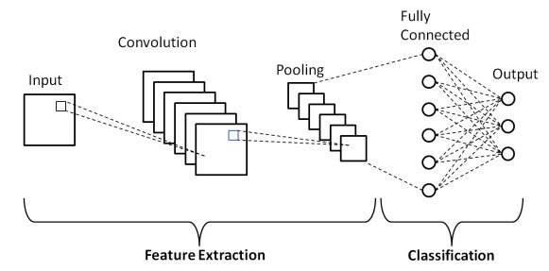

**Figure 1.** Theoretical framework of the study.

The architectural framework of a convolutional neural network based on the study by Phung & Rhee (2019), were divided into two parts: feature extraction and classification. According to Saha (2018), the input layer would take in an input image in one-dimensional tensor for grayscale images or three-dimensional tensor for colored images. Convolution would then be applied to the images for feature extraction of edges, color, etc with the use of kernels as filters. After the convolution operations, a feature map, a reduced version of the original tensor would have been generated. Dimensionality reduction would then be applied again on the feature maps in an operation called pooling, to decrease the computational power required to process the data in training. The rows of matrices would then be transformed into a single long column of data for classification of an artificial neural network in a process called flattening. Finally, the flattened vector would be used as inputs for the fully connected layers for the output layer.

This theoretical framework was taken as reference in developing the transfer learning-based convolutional neural network models. In transfer learning, to use the weights of a pre-trained convolutional neural network, their convolutional and pooling layers with their learned features would be integrated to another convolutional neural network for better performance and faster training time.

## Conceptual Framework

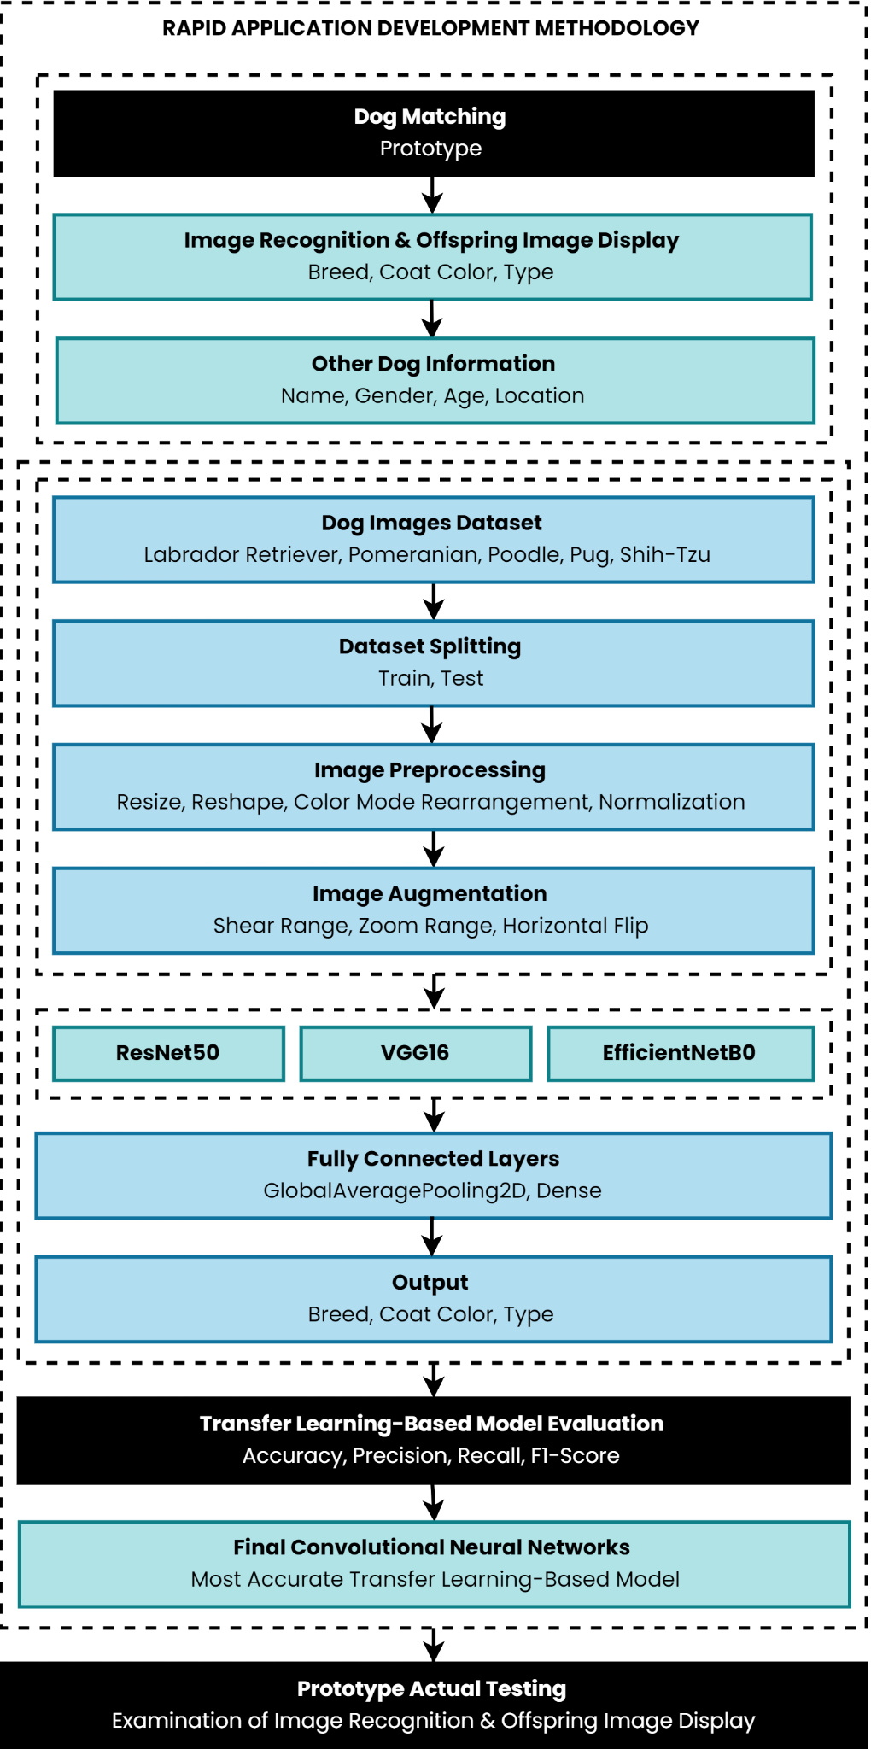

**Figure 2.** Conceptual framework of the study.

The roadmap taken, primarily derived from the objectives of the study, was shown in the figure above. The design and development of the prototype and the models were parts of the Rapid Application Development (RAD) software development methodology. The prototype developed was a dog matching web-based application. It had image recognition and offspring image display, primarily based on dog breeds, coat colors, and types as well as other information including name, gender, age, and location.

The dog image datasets collected from Google Images were based on the scope of breeds in this study: Labrador Retrievers, Pomeranians, Poodles, Pugs, and Shih-Tzus. The datasets were then prepared by manually splitting the images into train and test sets. After dataset splitting, they were then preprocessed through resize, reshape, color mode rearrangement, and normalization. Additionally, image augmentation techniques, including shear range, zoom range, and horizontal flip were applied to the already small datasets in order to add more data for training.

Once the train sets were preprocessed and augmented, the convolutional layers of pre-trained models, ResNet50, VGG16, and EfficientNetB0 take them as inputs. Next, fully connected layers, composed of global average pooling and dense layers, fed on the outputs of the convolutional layers. The outputs of the fully connected layers were then used for generating the prediction outputs: breed, coat color, and type of a dog.

After building transfer learning-based convolutional neural network model architectures, the best-performing pre-trained model from ResNet50, VGG16, and EfficientNetB0 was determined. Each developed transfer learning-based convolutional neural network model was evaluated for their accuracy, precision, recall, and F1-score. The most accurate transfer learning-based convolutional neural network model with its particular pre-trained convolutional neural network model was chosen by the researchers.

Finally, once the dog matching web application prototype had been developed, its predictions for image recognition and offspring image display were then examined by the researchers through a series of tests.

## Scope and Limitations of the Study

This section outlined the coverage and bounds of the study conducted by the researchers. The scope of the study included the following:

* The dog matching web application prototype had an image recognition of breeds, coat colors, and types as well as image display of offsprings for Labrador Retrievers, Pomeranians, Poodles, Pugs, and Shih-Tzus.
* The pre-trained CNN models involved in this study were ResNet50, VGG16, and EfficientNetB0.
* The researchers employed the model evaluation metrics for accuracy, precision, recall, and F1-score.
* The study covered the use of experimental and developmental research design methods.

However, this study was limited to the following:

* The dog breed images dataset collected was only limited to the breeds, namely, Labrador Retriever, Pomeranian, Poodle, Pug, and Shih-Tzu, and the dog coat colors images dataset collected was only limited to two particular colors and types for each breed within the scope of the study.
* The study did not cover the deployment or implementation of the system to be developed.

## Significance of the Study

In general, specific individuals or groups would benefit from this study and its system output. Specifically, this study would be beneficial to the following:

**Dog Owners.**Having a dog matching application would greatly benefit dog owners. Dog owners would be able to find preferred dog partners for their dogs more efficiently than traditional methods. This would result in a more precise result of searching for a matching dog partner.

**Dogs.**Although dogs don’t necessarily need to breed, frustration may come out of a lack of sexual interaction. This study may help encourage dog owners to breed their dogs.

**Computer Science Community.**The state-of-the-art image recognition algorithms, convolutional neural networks, played a crucial role in this study. This study could greatly benefit the computer science community to motivate them to further advance convolutional network models for better performance.

**Researchers.**This study would be beneficial to the present and future researchers who would be conducting a study related to image recognition. Also, the prototype output of this study could be used for further development.

**CHAPTER II**

# REVIEW OF RELATED LITERATURE

This chapter would present the review of related literature and studies; local and foreign, synthesis, and assessment of the different related literature and studies.

## Artificial Intelligence (AI)

The use of artificial intelligence was crucial for this study. According to the study by Boden (1996) entitled “Artificial Intelligence,” it was stated that it was the study of how to build or program computers to enable them to do what minds can do. In particular, the recognition of images by computers was applied to this study.

However, there were different branches of artificial intelligence that were considered by the researchers for image recognition. In the study entitled “6 Major Branches of Artificial Intelligence (AI),” by Tyagi (2020), the author stated that there were 6 branches of artificial intelligence. The branches were Machine Learning, Neural Network, Robotics, Expert Systems, Fuzzy Logic, and Natural Language Processing. Out of all the branches, the researchers decided to pursue the use of neural networks for this study.

The decision to pursue the branch, neural networks, was based on a specific reason. It was stated in the study entitled “Introduction to Neural Networks, Advantages and Applications” by Mahanta (2017) that artificial neural networks use the processing of the brain as their basis to develop algorithms that can be used to model complex patterns and prediction problems. This ensured that the models developed could make decisions on their own.

In addition to the study stated above, neural networks were extremely popular for computer vision tasks. According to the study by Serpa (2020) entitled “Why Neural Networks Are Great For Computer Vision,” neural networks were effective at handling complex inputs including images, audio, and text. It was mainly due to their natural capacity to aggregate tiny elements into complex abstractions. The meaningless pixels would be joined repeatedly to create patterns and patterns of patterns.

## Deep Learning

The application of neural networks as a branch of artificial intelligence was called deep learning. This was stated in the study entitled “AI vs. Machine Learning vs. Deep Learning vs. Neural Networks: What’s the Difference?,” by Kavlakoglu (2020) as being made up of neural networks. Moreover, it was the number of layers of nodes, or depth, of neural networks. A neural network would be called deep learning if it had more than three layers. Similarly, this study employed the use of deep learning with multiple numbers of parameters for neural networks.

Deep learning could be used to solve perceptual problems, such as image and speech recognition, effectively. The reason for this as stated in the study by Rusk (2016) entitled “Deep Learning,” was that deep learning uses multiple processing layers to discover patterns and structure in datasets of various sizes. Moreover, it does not depend on prior data processing unlike machine learning, where features would have to be manually extracted.

To extend the differences of deep learning to other methods, Middleton (2021) in the study entitled “Deep Learning vs. Machine Learning - What’s the Difference?,” stated that although machine learning requires less computational power, deep learning needs less ongoing human intervention. As a result of the aforementioned advantages of deep learning, deep learning was used often for image recognition. Image recognition or classification would be hard without the use of deep learning.

However, despite deep learning’s intimidating demeanor, it was similar to other approaches as well. For instance, according to the study entitled “Deep Learning,” by Lecun et al. (2015), it was stated that they still needed features to be extracted from raw data for model development. The extraction of features for images in this study was crucial to detect patterns, such as edges, colors, etc.

Deep learning was born through the advancements of technology. The study by Fu et al. (2022) entitled “The Role of Deep Learning in Urban Water Management: A Critical Review,” summarized the reasons specifically. The authors stated that it was due to the development of faster graphics processing units (GPU) and the availability of large datasets.

## Artificial Neural Network (ANN)

Before diving into the field of deep learning for image recognition, it was important to address what a neural network was. A neural network could also be called an artificial neural network (ANN), since it was just inspired by a simplification of neurons in a brain. According to the study by Mohseni-Dargah et al. (2022) entitled “Machine Learning in Surface Plasmon Resonance for Environmental Monitoring,” an artificial neural network was defined as consisting of input, hidden, and output layers with connected neurons or nodes to simulate the human brain.

As aforementioned, an artificial neural network would have an input, hidden, and output layer. This general structure made neural network models capable of making decisions on their own, close to what artificial intelligence actually meant. Based on the study by Malik (2019) in the study entitled “What Are Hidden Layers,” it was stated that there must always be at least one input layer in an artificial neural network. This layer would be in charge of receiving the data. Then, the neurons would do calculations on the input data before sending it to the hidden layer. The hidden layer would take in a set of weighted inputs. Finally, the output layer would be the last layer of neurons that would produce outputs.

There were many types of artificial neural networks. They were classified based on their structure, data flow, neurons, layers, etc. Since each type of artificial neural network had their differences, each type also had their own strengths. According to the study by Mehta (2022) entitled “A Comprehensive Guide to Types of Neural Networks,” it was stated that such types of artificial neural networks include Feedforward Neural Network, Radial Basis Function Neural Network, Multilayer Perceptron, Convolutional Neural Network, Recurrent Neural Network, Modular Neural Network, and Sequence-To-Sequence Models. But of all these types, convolutional neural networks were the most effective in image recognition.

## Convolutional Neural Network (CNN)

A convolutional neural network was a type of artificial neural network. According to the study by Mishra (2020) entitled “Convolutional Neural Networks, Explained,” a convolutional neural network (CNN), or ConvNet, specializes in processing data that has a grid-like topology, such as an image. A convolutional neural network typically has three layers: a convolutional layer, a pooling layer, and a fully connected layer, where the convolutional layer was its core building block.

As stated above, a convolutional layer was a fundamental component of a convolutional neural network. It would be responsible for performing feature extraction on input data, particularly images. Feature extraction in convolutional neural networks would be achieved through the process of convolution. Convolution as stated in the study by Yamashita (2018) entitled “Convolutional Neural Networks: An Overview and Application in Radiology,” was a specialized type of linear operation used for feature extraction, where a small array of numbers, called a kernel, would be applied across the input, which would be an array of numbers, also called a tensor.

Following the convolutional layers would be the pooling layers. According to the study by Seb (2021) entitled “What is Pooling in a Convolutional Neural Network (CNN): Pooling Layers Explained,” pooling in convolutional neural networks was a technique for generalizing features extracted by convolutional filters. Moreover, it was applied to help the network recognize features independent of their location in an image. Pooling was very similar to the convolution operation. In pooling, a filter, or kernel, of a common size of 2x2 would be slid over the input tensor. As a result, the huge computing resources that would be demanded from training a neural network from images would be sustainable. In other words, the number of parameters of the input tensor would be greatly reduced. Thus, overfitting would be reduced, representative features from input tensor would be extracted, and computation would be reduced. The most common methods to pooling were max pooling and average pooling.

Another method for pooling, aside from the previously stated pooling operations, would be the global average pooling. This pooling operation, according to the study by Lin et al. (2013) entitled “Network In Network,” was a pooling operation designed to replace fully connected layers in classical convolutional neural networks. The idea was to generate one feature map for each corresponding category of the classification task. Instead of adding fully connected layers on top of the feature maps, the average of each feature map would be taken. An advantage of using a global average pooling layer would be the avoidance of overfitting.

Lastly, the last essential component in a convolutional neural network would be the fully connected layers. In the study entitled “Convolutional Neural Network,” by Arc (2018), the author stated that a fully connected layer was simply a feed forward neural network. It would form the last few layers of a convolutional neural network. The input layer to the fully connected layer would be the flattened output of the final pooling or convolutional layer.

As stated above, the output of the final pooling or convolutional layer would be flattened, then fed into the input layer of the fully connected layer. Flattening in convolutional neural networks, as defined in the study by Jeong (2019) entitled “The Most Intuitive and Easiest Guide for Convolutional Neural Network,” was the conversion of data into a 1-dimensional array as an input to the following layer. Moreover, it was indicated that the flattened output of the pooling or convolutional layers would be a single long feature vector.

## ResNet

ResNet, or Residual Network, was one of the most popular convolutional neural networks to date. It was introduced by He et al. (2016) in their study entitled “Deep Residual Learning for Image Recognition” in 2015. The main reason was due to a problem with training deep neural networks. The accuracy of a neural network would typically increase with the increasing number of layers. As a result, the architectures of deep neural networks have become deeper and deeper over the years. However, a plateau or decrease in the neural network’s performance would come once it hits a certain number of layers. ResNet’s popularity was due to its ability to ease the training of such deep neural networks. In addition, it could steadily increase the deep neural networks’ accuracy, unlike the typical neural networks that decrease or saturate the accuracy along an early point in the training process.

As stated above, the training of deep networks would typically result in the saturation and decrease in performance once it hits a certain number of layers. Fortunately, this problem could be resolved with the introduction of residual blocks. According to the study by Shakhadri (2021) entitled “Build ResNet from Scratch With Python !,” ResNet was made up of these residual blocks.

Residual blocks would be simple to understand. It was explained perfectly in the study by Sahoo (2018) entitled “Residual Blocks - Building Blocks of ResNet.” The author mentioned that in a typical or traditional neural network, each layer would feed into the next layer. However, in a neural network made up of residual blocks, each layer would feed into the next layer and directly into the layers about 2-3 hops away.

There could be different numbers of layers for a ResNet convolutional Network. But, the most popular and widely used type of ResNet was ResNet50. Architecturally, ResNet50 contained 50 convolutional and fully connected layers as mentioned in the study by Ji et al. (2021) entitled “Soft Fault Diagnosis of Analog Circuits Based on a ResNet with Circuit Spectrum Map.” The 50 layers mentioned were divided into 48 convolutional layers, one MaxPool layer, and one average pool layer.

Performance-wise, it could be said that the performance of ResNet50 was pretty accurate. An example of a performance evaluation was conducted in the study by Ayanzadeh & Vahidnia (2018) entitled “Modified Deep Neural Networks for Dog Breed Identification.” In their study, the authors achieved a test accuracy of 89.66% using ResNet50 for dog breed classification. The dataset used in their study was the Stanford Dogs Dataset, which contained 120 dog breeds and 20,580 images for training and testing.

Moreover, the study by Boteju et al. (2020) entitled “Deep Learning Based Dog Behavioural Monitoring System,” showed a similar result in performance for ResNet50. But, beyond dog breed classification, their study further classified the behaviour of dogs, including walking, resting, and barking. Their study achieved an accuracy level of 89% for breed recognition. 99.5% for walking pattern recognition, 97% for resting pattern recognition, and 60% on barking pattern recognition. The dataset used in their study was the Columbia Dogs with Parts dataset, containing 135 dog breeds.

## VGG

Another type of convolutional neural network was VGG, which stood for Visual Geometry Group. It was proposed by Simonyan & Zisserman (2014) based on their study entitled “Very Deep Convolutional Networks for Large-scale Image Recognition.” Similar to the aforementioned model architecture, VGG was known to be a popular model architecture for use.  
 However, unlike ResNet which was made up of stacked residual blocks, VGG, according to the study by Boesch (2021) entitled “VGG Very Deep Convolutional Networks (VGGNet) – What You Need to Know,” was a standard deep convolutional neural network architecture with multiple layers, wherein each layer consisted of blocks. Each block was composed of 2D Convolution and Max Pooling layers.

There could also be different numbers of layers for a VGG model. The first proposed VGG model was VGG16. It was a model that was 16 layers deep as mentioned in the study by Theckedath (2020) entitled “Detecting Affect States Using VGG16, ResNet50 and SE-ResNet50 Networks.” Moreover, the author stated it had a small receptive field of 3×3. Also, it had a Max pooling layer of size 2×2 and had a total of 5 such layers. Next, there were three fully connected layers after the last Max pooling layer. This was followed by three fully connected layers. It used the softmax classifier as the final layer. ReLu activation would be applied to all hidden layers.

As a result of the extensive training that the VGG16 neural network had undergone, it could give excellent accuracy regardless if the image datasets were small. The study by Tammina (2019) entitled “Transfer Learning Using VGG-16 with Deep Convolutional Neural Network for Classifying Images,” performed a performance evaluation of VGG16. The author’s study was to classify cats and dogs. The dataset used was a total of 25000 images of cats and dogs. The VGG16 model achieved a test accuracy of 95.40%.

Moreover, according to the study by Karthick (2018) entitled “Deep Learning For Age Group Classification System,” the author performed another performance evaluation for VGG16. However, the dataset used was from the MORPH database, containing classified age groups of people, such as senior adult, adolescence and adult. Their study achieved a classification accuracy of over 90% for all age groups using the VGG16 model architecture.

## EfficientNet

Lastly, the convolutional neural network used according to the scope of this study was EfficientNet. It was a convolutional neural network model architecture based on the study by Tan & Le (2019) entitled “EfficientNet: Rethinking Model Scaling for Convolutional Neural Networks.” It was another type of model architecture that had its advantage over other types of model architectures.

As stated above, EfficientNet model architecture had its own advantage. Its advantage was based on a novel model scaling method. According to the study Kumar (2020) entitled “Implementing EfficientNet: A Powerful Convolutional Neural Network,” it was mentioned that it used a simple yet highly effective compound coefficient to scale up CNNs in a more structured manner.

Having to scale CNNs in a more structured manner was crucial to increase the neural network’s performance. According to the study by Szegedy et al. (2015) entitled “Going Deeper with Convolutions,” it was stated that many researchers have been trying to scale the width of a neural network. Moreover, according to the study by He et al. (2016) entitled “Deep Residual Learning for Image Recognition,” it was stated that many researchers have been trying to scale the depth of a neural network. Moreover, according to the study by Huang et al. (2019) entitled “Gpipe: Efficient Training of Giant Neural Networks Using Pipeline Parallelism,” it was stated that many researchers were also trying to scale the resolution of images. However, none of them defined how to balance all the dimensions with a proper ratio. The size of input resolution was a crucial aspect for the model to achieve a superior performance. Therefore, EfficientNets was able to be more structured by carefully balancing the depth, width, and resolution of the network in order to have better performance.

Basically, EfficientNet was a family model that was built from a baseline model which developed through a neural architecture search based on the study by Zoph & Le (2017) entitled “Neural Architecture Search with Reinforcement Learning.” The baseline model was EfficientNetB0. The following models were incremented up to EfficientNetB7.

As aforementioned, EfficientNets were developed through neural architecture. Basically, the neural architecture search was a framework to search for the best architecture in the search space under certain constraints. According to the study proposed by Sandler et al. entitled “Mobilenetv2: Inverted Residuals and Linear Bottlenecks.”, it was stated that the main building block of the network was a mobile inverted bottleneck (MBConv) layer.

In terms of the performance of the baseline model of EfficientNets, EfficientNetB0, several studies had conducted performance evaluations. For instance, in the study by Stock & Cavey (2021) entitled “Who's a Good Boy? Reinforcing Canine Behavior in Real-Time using Machine Learning,” it was stated that the EfficientNetB0 model achieved 90.79% test accuracy for dog behavior classification. The dataset the researchers used was the Stanford Dogs Dataset. It was composed of 20,578 total RGB images, containing 120 different dog breeds in different scenes with varying lighting conditions and resolutions. The researchers manually hand-labeled a set of four dog actions, namely, standing, sitting, lying down, and undefined.

## Transfer Learning

In order to use the model architectures mentioned above on a similar problem, transfer learning was needed to be used for this study. According to the study by Donges (2022) entitled “What Is Transfer Learning? Exploring the Popular Deep Learning Approach,” transfer learning was defined as the the reuse of a pre-trained model on a new problem. It was very popular in deep learning because it could train deep neural networks with comparatively small datasets. This would be very useful in the data science field since most real-world problems typically do not have millions of labeled data points to train such complex models.

The reason transfer learning would work for this study was because the pre-trained models: ResNet50, VGG16, EfficientB0, were trained using the ImageNet dataset. According to the study by Deng et al. (2009) entitled “ImageNet: A Large-Scale Hierarchical Image Database,” ImageNet dataset consisted of 1000 classes. Most importantly, the classes contained dogs. Each class contained around 1300 training images and 50,000 test images in total. The images had a resolution of 224 × 224 × 3.

In convolutional neural networks, transfer learning could be thought of as a design methodology. The study by Koehrsen (2018) entitled “Transfer Learning with Convolutional Neural Networks in PyTorch,” explained the concept behind transfer learning for image recognition. The author explained that instead of building and training a CNN from scratch, pre-trained models would be used to apply transfer learning. For image recognition with a CNN, the early convolutional layers of the network would be freezed and only the last few layers which make a prediction would be trained. In other words, the convolutional layers would be freezed, and only the fully connected layers would remain.

Transfer learning had a wide range of benefits for model development. According to Seldon (2021) in the study entitled “Transfer Learning for Machine Learning,” it was stated that such advantages included the removal of the need for a large set of labeled training data for every new model, the efficiency of machine learning development and deployment for multiple models, more generalised approach to machine problem solving, leveraging different algorithms to solve new challenges, and models could be trained within simulations instead of real-world environments.

## Image Classification Evaluation Metrics

Evaluating algorithm models was considered an essential part of any machine learning or deep learning projects. To evaluate an image classification model, the datasets would first need to be processed manually. According to the study by Gour (2019) entitled “Train and Test Set in Python Machine Learning - How to Split,” it was stated that the process would come in two stages. The image dataset would be manually split around 20%-80%. The 80% would normally be the train set that would be used to build the image classifier. On the other hand, the 20% part of the dataset would be the test set that would be used to evaluate the model.

The technique mentioned above was called the train-test-split evaluation. According to the study by Brownlee (2020) entitled “Train-Test Split for Evaluating Machine Learning Algorithms,” it was stated that it could be used for classification or regression problems as long as they were used for supervised learning algorithms. The objective of the evaluation was to estimate the performance of the model on new data that hasn’t been used to train the model. In practice, this was how it was expected for the model to be used, which was to fit it on available data with known inputs and outputs, then make predictions on new examples in the future.

For classification algorithms, including image classification algorithms, there were a couple of metrics used to evaluate their performance. The classification metrics were based on the confusion matrix. According to the study by Suresh (2020) entitled “What is a Confusion Matrix?,” confusion matrix was defined as a tabular summary of the number of correct and incorrect predictions made by a classifier. It was grouped into four categories namely, True Positive (TP) wherein both the actual and predicted values were 1, True Negative (TN) wherein both the actual and predicted values were 0, False Positive (FP) wherein the actual value was 0 but the predicted value was 1, and False Negative (FN) wherein the actual value was 1 but the predicted value was 0. The confusion matrix could be used to measure the performance of a classification model. Moreover, it could be used to evaluate the performance of a classification model through the calculation of performance metrics like accuracy, precision, recall, and F1-score.

Accuracy was defined in the study by Agrawal (2021) entitled “Metrics to Evaluate Your Classification Model to Take the Right Decisions” as the ratio of the number of correct predictions and the total number of predictions. Simply, it was the measure of how often the classifier correctly predicts.

Next, precision was defined in the study by Fernández et al. (2018) entitled “Learning from Imbalanced Data Sets,” as a metric that quantifies the number of correct positive predictions made. Precision, therefore, calculates the accuracy for the minority class. Precision would evaluates the fraction of correctly classified instances among the ones classified as positive

Following, recall was defined in the study by Ma et al. (2013) entitled “Imbalanced Learning: Foundations, Algorithms, and Applications,” as a metric that quantifies the number of correct positive predictions made out of all positive predictions that could have been made. Unlike precision, which only comments on the correct positive predictions out of all positive predictions, recall could provide an indication of missed positive predictions.

Finally, F1-score was defined in the study Fong & Biuk-Aghai (2009) entitled “An Automated University Admission Recommender System for Secondary School Students,” as a metric that conveyed the balance between the recall and the precision. Moreover, it could provide a way to express both concerns with a single score.

## Dog Breeding

This study was focused entirely on finding partners for dogs. For years dogs have been present in almost every human society and are among the most popular pets, according to the study by Archer (1997) entitled “Why do People Love their Pets.” Moreover, they were also the earliest domesticated animal species, with fossil evidence indicating that dogs and humans have lived alongside one another for thousands of years

Today, the roles of dogs have changed. According to the study by King et al. (2012) entitled “Breeding Dogs for Beauty and Behaviour: Why Scientists Need to do More to Develop Valid and Reliable Behaviour Assessments for Dogs Kept as Companions,” it was stated that it was more important to take physical health and behaviour, as well as perceived beauty, into consideration when breeding and selecting dogs as companions.

In addition, according to the study by Hirst (2019) entitled “The Selective Breeding of Dogs,” it was stated that when an interesting or useful trait was identified in a dog, owners would breed from that dog in the hope of the trait being passed on. Over many rounds of such breeding attempts, especially where two dogs with the same trait would be bred with each other, traits became fixed.

## Synthesis

In conducting this study, several artificial intelligence (AI) theories were looked into for image classification. But, only one branch out of the six branches of artificial intelligence was used for this study. The determined branch of AI chosen by the researchers was neural networks, which was defined by Mahanta (2017). The reason this was chosen by the researchers was because it was extremely popular for computer vision tasks. Moreover, neural networks were effective at handling complex input, such as images, which was perfect for classification of images of dogs.

In general, a single neural network won’t be enough to build an accurate image classifier. A set of neural networks would be needed for this study. Rusk (2016) referred to this as deep learning. Through deep learning, Lecun et al. (2015) stated that features extraction would be done for the image datasets. This would allow the extraction of features, such as edges, colors, etc. Moreover, Fu et al. stated that deep learning would be really necessary because of the advancement of technology.

Technically, a neural network could also be called an artificial neural network (ANN). The reason was because as stated by Mohseni-Dargah et al. (2022), it consisted of input, hidden, and output layers with connected neurons inspired from the human brain. Malik (2019) then explained the responsibility of the input layer, hidden layers, and output layer. For image recognition, Mehta (2022) stated that there were many types of neural networks, but of all the types mentioned, convolutional neural networks was used for this study, since it was the most effective for image classification or recognition.

In this study, convolutional neural networks were used for image recognition. Mishra (2020) stated that it typically has three layers, namely, a convolutional layer, a pooling layer, and a fully connected layer. For convolutional layers, Yamashita (2018) discussed its process. For pooling layers, Seb (2021) explained its importance, including the common types of pooling, and why the global average pooling was used for this study. In fully connected layers, Arc (2018) explained its process as the last part of a convolutional neural network, including the structure of input it accepts.

For this study, several model architectures of convolutional neural networks were used. The first type of model was ResNet, which was defined by Shakhadri (2021), particularly ResNet50. The reason ResNet was developed was discussed by He et al. (2016). Architecturally, Ji et al. (2021) discussed its composition. In terms of its performance, Ayanzadeh & Vahidnia (2018) conducted a performance evaluation.

The second type of convolutional network used for this study was VGG, which was defined by Boesch (2021), particularly VGG16. In terms of its performance, the study by Tammina (2019) performed testing for its accuracy.

The last type of model architecture used for this study was EfficientNet, which was defined by Kumar (2020), particularly EfficientNetB0. He et al. (2016) then mentioned the advantage of EfficientNet. In terms of its performance, the EfficientNetB0, which was the baseline model for the family of EfficientNets according to Zoph & Le (2017), was evaluated in the study by Stock & Cavey (2021) for accuracy.

But, without the application of transfer learning, which was defined by Donges (2022), this study wouldn’t be possible. The design methodology of transfer learning was further discussed by Koehrsen (2018).

In order to evaluate the transfer learning-based models for this study, the accuracy metric which was defined by Agrawal (2021), precision metric which was defined by Fernández et al. (2018), recall metric which was defined by Ma et al. (2013), and F1-score metric which was defined by Fong & Biuk-Aghai (2009), based on the confusion matrix which was defined by Suresh (2020), were used.

Overall, this study was focused on dogs, particularly breeding. King et al. (2012) mentioned that nowadays, it was more important for dogs to be perceived based on their beauty when breeding. This was further discussed by Hirst (2019), stating that when an interesting or useful trait was identified in a dog, owners would breed from that dog in the hope of the trait being passed on.

**CHAPTER III**

# RESEARCH METHODOLOGY

In this chapter, the methodologies employed by the researchers to accomplish the objectives of the study would be presented. It would enumerate the research design, fact-finding technique, algorithm analysis, data model generation, model evaluation, image recognition, offspring image display, development methodology, prototype actual testing, and software used in the development.

## Research Design

This study was conducted with the use of experimental and developmental research design methods. As stated by Arikunto (2006), an experimental research design was a study that aimed to know if there was an effect on the variable being studied. This method was utilized in order to determine the best-performing pre-trained convolutional neural network model in terms of image classification with respect to the datasets collected.

Furthermore, as defined by Richey (1994), developmental research was the systematic study of designing, developing, and evaluating instructional programs, processes, and products that must meet the criteria of internal consistency and effectiveness. The researchers used developmental research to determine the features to be developed for the system. It was also used to assess the system's consistency and efficacy during development.

## Fact-Finding Technique

This section would discuss the thorough review of the technique used to collect important information, crucial to accomplish the objectives of the study. It was discussed in the following:

***Online Research***

Several methods were conducted through online research. First, preliminary investigations were conducted to establish the research problem, and to determine the scope of breeds, coat colors, and types of dogs. Second, data collection was conducted for image datasets. Last, a thorough knowledge of the development process for the prototype was conducted.

In conducting the preliminary investigations, it was determined that indeed finding a dog breeding partner consumed a lot of time and effort because of the need to look thoroughly through each Facebook post and contact various breeders just to find the preferred one. Before collecting the image datasets, the top five most common breeds in the Philippines as of March 2022 based on the study by Co (2022) was determined as the scope for dog breeds in this study. In terms of their coat colors, two coat colors for each breed were selected for this study. Moreover, in terms of their types, two types for each breed except for pugs, were selected for this study, since pugs were differentiated based on their coat colors only.

**Table 1*.***Scope of breeds, coat colors, and types.

|  |  |  |
| --- | --- | --- |
| **BREED** | **COAT COLORS** | **TYPES** |
| Labrador Retriever | Black, Brown | American, English |
| Pomeranian | Black, White | Baby Doll, Fox Face |
| Poodle | Black, White | Standard, Toy |
| Pug | Black, Fawn | - |
| Shih-Tzu | Black, White | American, European |

The summary of the preliminary investigations on the scope of breeds, coat colors, and types were shown in the table above.

In collecting the datasets, the images of the particular dog breeds along with two of their coat colors and two of their types were able to be validated and found with the use of Google Images. Each image was manually downloaded and categorized into respective folders using a file manager application, File Explorer.

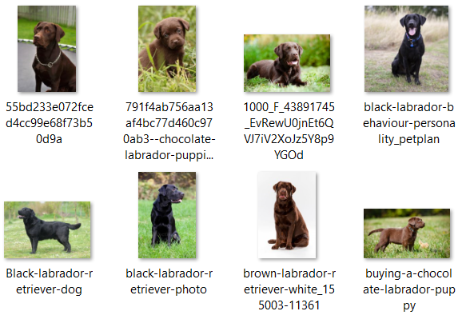

**Figure 3*.***Screenshot of Labrador Retriever images.

A screenshot of Labrador Retrievers images having various coat colors and types from its categorized folder was shown in the figure above.

**Table 2*.***Summary of the collected breed images dataset.

|  |  |
| --- | --- |
| **BREED** | **BREED IMAGES** |
| Labrador Retriever | 36 |
| Pomeranian | 36 |
| Poodle | 36 |
| Pug | 36 |
| Shih-Tzu | 36 |
| **TOTAL** | **180** |

A total of 180 dog breed images were collected for this study. Based on the table above, the dog breed images were categorized into their own breeds. Each categorical breed had 36 images. The dataset was split and preprocessed for feature extraction in convolutional layers later on.

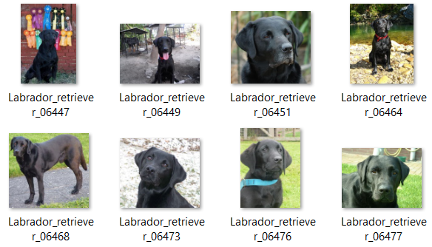

**Figure 4*.***Screenshot of black Labrador Retriever images.

A screenshot of black Labrador Retriever images from its respective folder was shown in the figure above.

**Table 3*.***Summary of the collected coat color images dataset.

|  |  |  |
| --- | --- | --- |
| **BREED** | **COAT COLOR** | **COAT COLOR IMAGES** |
| Labrador Retriever | Black | 18 |
| Brown | 18 |
| Pomeranian | Black | 18 |
| White | 18 |
| Poodle | Black | 18 |
| White | 18 |
| Pug | Black | 18 |
| Fawn | 18 |
| Shih-Tzu | Black | 18 |
| White | 18 |
| **TOTAL** | | **180** |

A total of 180 images for the dog breed’s coat color were collected for this study. Based on the table above, the dog coat colors were categorized into their own coat colors for a particular breed. Like the previous dataset, this dataset was split and preprocessed for feature extraction in convolutional layers in due course.

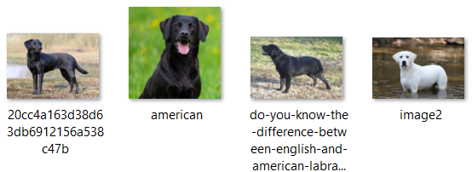

**Figure 5*.***Screenshot of American Labrador Retriever images.

A screenshot of American Labrador Retrievers images from its respective folder was shown in the figure above.

**Table 4*.***Summary of the collected type images dataset.

|  |  |  |
| --- | --- | --- |
| **BREED** | **TYPE** | **TYPE IMAGES** |
| Labrador Retriever | American | 18 |
| English | 18 |
| Pomeranian | Baby Doll | 18 |
| Fox Face | 18 |
| Poodle | Standard | 18 |
| Toy | 18 |
| Pug | - | - |
| - | - |
| Shih-Tzu | American | 18 |
| European | 18 |
| **TOTAL** | | **144** |

A total of 144 images for the dog breed’s types were collected for this study. Based on the table above, the dog types were categorized into their own type for a particular breed. Also, like the previous datasets, this dataset was split and preprocessed for feature extraction in convolutional layers in due course.

In acquiring a thorough knowledge of the development process to build the web application prototype, Dinder, the necessary skills and knowledge were studied. The vast number of resources available online enabled the study for deep neural networks, particularly image recognition.

## Algorithm Analysis

The use of deep neural networks for image recognition was chosen for this study. However, training a deep neural network from scratch required a significant amount of time, datasets, and memory for an accurate model. Therefore, since the image datasets for this study were small, transfer learning was integrated. It referred to the transfer of knowledge gained from a previously trained deep neural network model. The use of transfer learning made it possible to train even small datasets. Moreover, the training time and memory usage was significantly less.

A popular approach to the utilization of transfer learning was through the Keras library. It was a high-level, deep learning API developed by Google for implementing neural networks. Keras had convolutional neural network models which were trained and validated on the ImageNet dataset that contained 1000 object classes and over 1.2 million images. For the purpose of this study, four pre-trained models with distinct numbers of parameters were considered and evaluated. The said pre-trained models were discussed in the following:

***ResNet50***

According to Dwivedi (2019), ResNet, short for Residual Networks, was a classic neural network used as a backbone for many computer vision tasks. Moreover, the author stated that it won the ImageNet challenge in 2015.

ResNet50 was a convolutional neural network 50 layers deep, composed of 48 convolutional layers along with 1 MaxPool and 1 Average Pool layer, trained on over a million images on the ImageNet database. According to the Keras library, this model has a total of 25.6 million parameters, which refers to the learned weights during training.

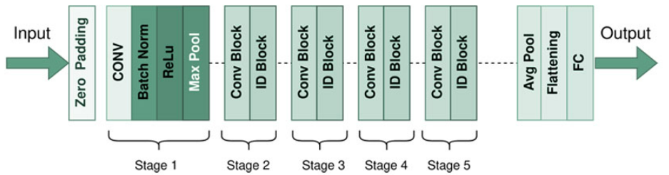

**Figure 6.** ResNet50 model architecture.

According to the figure above, the ResNet50 model consists of 5 stages each with a convolution and Identity block. Each convolution block had 3 convolutional layers and each identity block also had 3 convolutional layers.

This was chosen as one of the transfer learning models for testing since it had 25.6 million parameters.

***VGG16***

According to Rohini (2021), VGG16 was considered to be one of the best computer vision models to date, and it had also won the 2014 ImageNet challenge.

Unlike the aforementioned model, the number on VGG16 refers to its number of layers that have weights. It consists of 13 convolutional layers, 5 max pooling layers, and 3 dense layers which sum up to 21 layers, but it only accounted for the 16 layers that were learnable parameters layers. According to the Keras library, this model has a total of 138 million parameters, which refers to the learned weights during training.

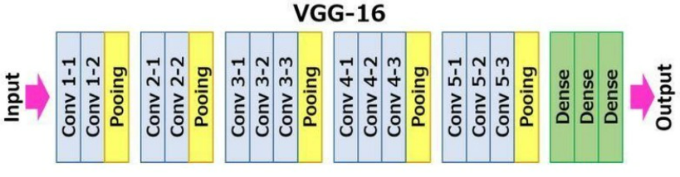

**Figure 7.** VGG16 model architecture.

According to the figure above, each convolutional layer of VGG16 was composed of 2 convolutional layers with 1 max pooling layer. The 16 convolutional layers could be summarized as Conv-1 Layer having 64 number of filters, Conv-2 having 128 filters, Conv-3 having 256 filters, and Conv-4 and Conv-5 having 512 filters.

This was chosen as one of the transfer learning models for testing since it was a pretty large network that has 138 million parameters.

***EfficientB0***

According to Sarkar (2021), EfficientNet used a method called compound coefficient to scale up models in an easy but efficient way. Compound scaling uniformly scales each dimension with a predetermined fixed set of scaling coefficients as opposed to randomly increasing width, depth, or resolution.

EfficientNetB0 was considered as the baseline model for the family of EfficientNets. Moreover, it achieved state of the art accuracy on ImageNet while being very efficient to its competitors. According to the Keras library, this model has a total of only 5.3 million parameters, which was significantly less than the previously mentioned pre-trained models.

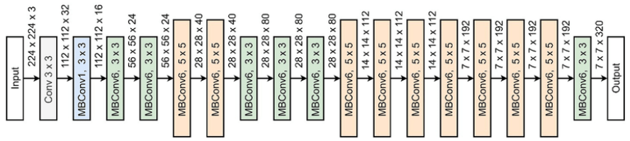

**Figure 8.** EfficientNetB0 model architecture.

According to the study by Alhichri et al. (2021), several observations could be made on the figure above. Some observations made were that it was composed of repeated MBConv1, MBConv3, MBConv6 blocks, which were basically different types of MBConv blocks in which according to Ahmed & Sabab (2020), MBConv layer was basically an inverted residual block originally applied in MobileNetV2, and that inside each block the number of channels were increased or expanded through a larger number of filters.

This was chosen as one of the transfer learning models for testing since it had only 5.3 million parameters.

## Data Model Generation

This section would enumerate the various methodologies employed in developing the algorithm models. It would include splitting the datasets into train and test sets, image preprocessing, image augmentation, and training the transfer learning-based models.

***Dataset Splitting***

The technique of splitting a dataset, based on Brownlee (2020), was used to evaluate the performance of algorithms when they would be used to make predictions on data that were not yet seen by a trained model.

**Table 5*.***Train-test split of the collected datasets.

|  |  |  |  |
| --- | --- | --- | --- |
| **SET** | **BREEDS DATASET** | **COAT COLORS DATASET** | **TYPES DATASET** |
| Train set | 150 images | 150 images | 120 images |
| Test set | 30 images | 30 images | 24 images |

The datasets for the breed and coat color images were split into 150 images for the train set and 30 images for the test set. On the other hand, the dataset for the types was split 120 images for the train set and 24 images for the test set.

***Image Preprocessing***

Images come in different shapes and sizes. Image preprocessing, according to Nelson (2020), referred to steps taken to format images before they would be used for training models. The image processing techniques employed were discussed in the following:

***Resize***

Since the pre-trained models would be the ones to process the input images, Keras indicated that it would be required to change the input shape of images to (224, 224, 3), with 224 being the dimensions of the images in pixels, and 3 being the number of color channels represented as RGB for colored images.

***Reshape***

Moreover, the dimensions for training the images had to be expanded to account for the number of images to train wherein (224, 224, 3) would be expanded to (n, 224, 224, 3) where n would be the number of images.

***Color Mode Rearrangement***

Since image processing involves the use of OpenCV, a huge open-source library for computer vision, it defaults reading images into BGR. Therefore, images in RGB were rearranged into BGR.

***Normalization***

The images originally contained color channel coefficients in the range of 0-255, but such values would be too high for models to process, so the range was scaled between 0 and 1 by simply dividing the individual pixel values of images by 255.

***Image Augmentation***

The image datasets collected for this study were very small in size. In order to have somewhat of an accurate model, image augmentation was applied to the image datasets. Image augmentation, according to Saxena (2021), was a technique of altering the existing data to create some more data for the model training process in order to increase the size of training data, prevent overfitting, and help the models generalize better. For each iteration in training, an additional of 10 images would be produced. The image augmentation techniques employed were discussed in the following:

***Shear Range***

It was used for randomly applying shear transformations wherein images would be distorted along an axis, mostly to create or rectify the perception angles.

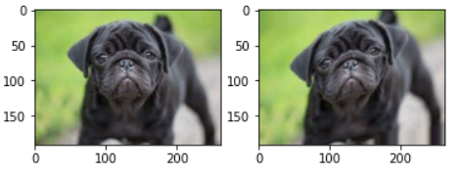

**Figure 9.** Shear range image augmentation.

A dog image from the image datasets in this study before and after applying a shear transformation was shown in the figure above.

***Zoom Range***

It was used to zoom into an image. It involved the process of randomly zooming the image either by zooming in or it adds some pixels around the image to enlarge the image.

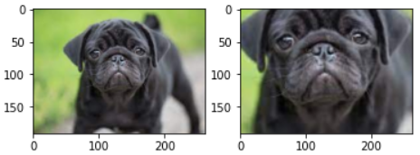

**Figure 10.** Zoom range image augmentation.

A dog image from the image datasets in this study before and after applying a zoom range transformation was shown in the figure above.

***Horizontal Flip***

It was used to basically flip both rows and columns of images horizontally.

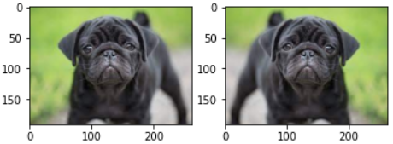

**Figure 11.** Horizontal flip image augmentation.

A dog image from the image datasets in this study before and after applying a horizontal flip transformation was shown in the figure above.

***Training***

Generally, in order to train and develop a neural network model, the model architecture had to be given an input layer, hidden layers, and an output layer. In a convolutional neural network, its input layer would be images, its hidden layers would be convolutional layers, and its output layer would be fully connected layers. However, in a transfer learning-based convolutional neural network, its hidden layers would be convolutional layers from pre-trained convolutional neural networks.

In training, the three image datasets: breeds dataset, coat colors dataset, and types dataset were used to train three image classification models: breed classification, coat color classification, and type classification. Each model was a transfer learning-based convolutional neural network model, with the pre-trained model to be determined in model evaluation.

The training phase for each pre-trained model in a transfer learning-based convolutional neural network model were discussed in the following:

***ResNet50 Transfer Learning-Based Model***

The ResNet50 transfer learning-based model was given the train set of preprocessed input images, the convolutional layers of ResNet50, and fully connected layers with GlobalAveragePooling2D and dense layers. Finally, the output was a dense layer with the number of nodes depending on the number of classes to predict. The model was trained through an epoch of 1 and a batch size of 32.

***VGG16 Transfer Learning-Based Model***

The VGG16 transfer learning-based model was given the train set of preprocessed input images, the convolutional layers of VGG16, and fully connected layers with GlobalAveragePooling2D and dense layers. Finally, the output was a dense layer with the number of nodes depending on the number of classes to predict. The model was trained through an epoch of 1 and a batch size of 32.

***EfficientNetB0 Transfer Learning-Based Model***

The EfficientNetB0 transfer learning-based model was given the train set of preprocessed input images, the convolutional layers of EfficientNetB0, and fully connected layers with GlobalAveragePooling2D and dense layers. Finally, the output was a dense layer with the number of nodes depending on the number of classes to predict. The model was trained through an epoch of 1 and a batch size of 32.

## Model Evaluation

In order to calculate the performance of the transfer learning-based convolutional neural network models, they would need to be run through a test set. The transfer learning-based model used for evaluation was the dog breed classifier only. Moreover, the test set used for evaluation was from the breed images dataset only. This was due to the fact that testing on the other developed transfer learning-based convolutional neural network models as well would just return the same performance levels.

Since the models were used on the prediction of category labels, the metrics for classification algorithms that were based on the confusion matrix were used.

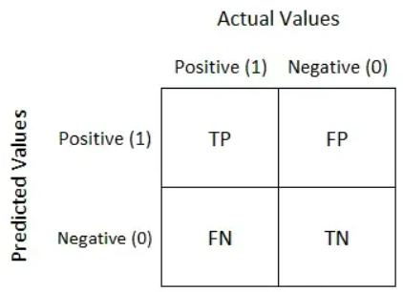

**Figure 12.** Confusion matrix.

A confusion matrix was simply a table used to define the performance of classification algorithms, where:

* True Positive (TP) referred to the total number of correctly predicted positive data points;
* True Negative (TN) referred to the total number of correctly predicted negative data points;
* False Positive (FP) referred to the total number of incorrectly predicted positive data points;
* False Negative (FN) referred to the total number of incorrectly predicted negative data points;

The metrics, derived from the confusion matrix, used to measure the performance of the models were discussed in the following:

## *Accuracy*



**Figure 13.** Accuracy formula.

The accuracy of a model would measure how often the classifier correctly predicts. It can be defined as the ratio of the number of correct predictions and the total number of predictions.

***Precision***

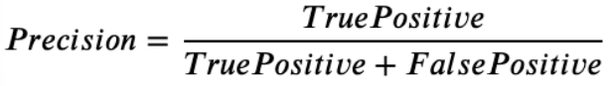

**Figure 14.** Precision formula.

The precision of a model would explain how many of the correctly predicted cases actually turned out to be positive. It can be defined as the number of true positives divided by the number of predicted values.

***Recall***

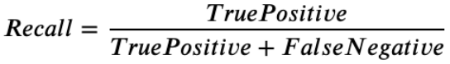

**Figure 15.** Recall formula.

The recall of a model would explain how many of the actual positive cases were able to be correctly predicted. It can be defined as the number of true positives divided by the total number of actual positives.

***F1-Score***

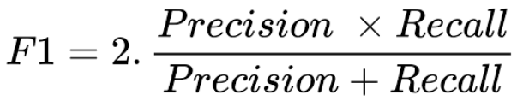

**Figure 16.** F1-score formula.

The F1-score of a model would give a combined idea about the precision and recall metrics. It would be maximum when precision would be equal to recall. It can be defined as the harmonic mean of precision and recall.

## Image Recognition

The prototype application of this study had the functionality to recognize or classify breeds, coat colors, and types of dogs. This was accomplished through the integration of the determined transfer learning-based convolutional neural network models. The image recognition methods for an input image were discussed in the following:

***Breed***

In classifying the breed of a dog, the input image would first be preprocessed through *image resize* and *image reshape* as the model required a particular input shape. The result of the image preprocessing techniques would be a 4D image tensor or array with the shape (1, 224, 224, 3). Finally, the preprocessed image input would be fed into the dog breed image classifier model that would return the breed of the dog.

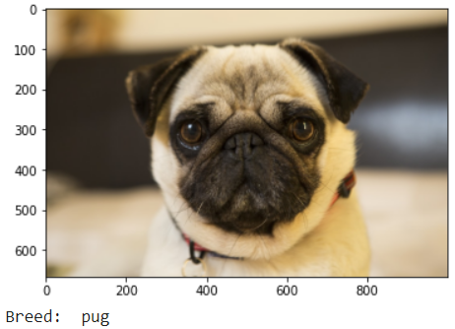

**Figure 17.** Breed classifier prediction.

A screenshot of the prediction of the dog breed classifier that predicted the input image to be *pug* was shown in the figure above.

***Coat Color***

Similarly, in classifying the coat color of a dog, the input image would first be preprocessed through *image resize* and *image reshape* as the model required a particular input shape. The result of the image preprocessing techniques would be a 4D image tensor or array with the shape (1, 224, 224, 3). Finally, the preprocessed image input would be fed into the dog coat color image classifier model that would return the coat color of the dog.

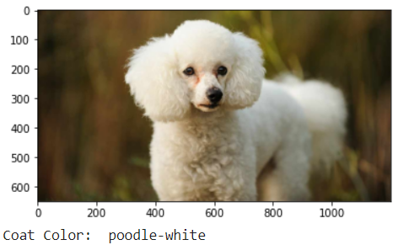

**Figure 18.** Coat color classifier prediction.

A screenshot of the prediction of the dog coat classifier that predicted the input image to be *poodle-white* was shown in the figure above.

***Type***

Similarly, in classifying the type of a dog, the input image would first be preprocessed through *image resize* and *image reshape* as the model required a particular input shape. The result of the image preprocessing techniques would be a 4D image tensor or array with the shape (1, 224, 224, 3). Finally, the preprocessed image input would be fed into the type classifier model that would return the type of the dog.

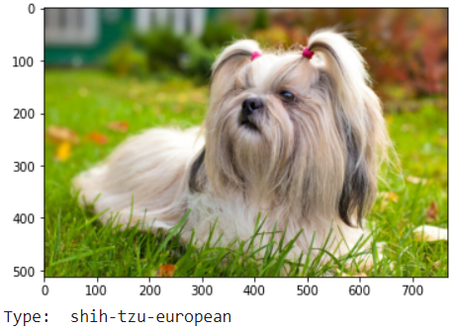

**Figure 19.** Type classifier prediction.

A screenshot of the prediction of the dog type classifier that predicted the input image to be *shih-tzu-european* was shown in the figure above.

## Offspring Image Display

Apart from image recognition, the prototype application of this study was built with the functionality to display possible offsprings of dogs that had matched with each other. In order to return and display the possible offspring images, various images for possible matches of breeds and coat colors first had to be prepared and downloaded from Google Images.

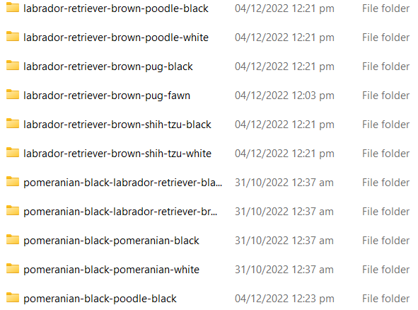

**Figure 20.** Offspring images folders.

A screenshot of the prepared categorized folders containing the downloaded possible offspring images was shown in the figure above. The folders were named after every possible match based on the scope of the breeds and coat colors of this study.

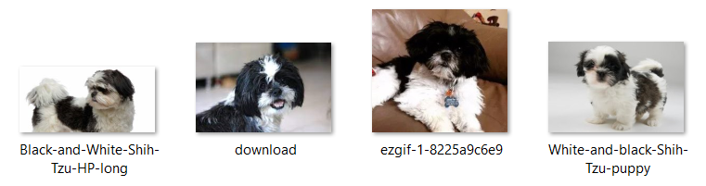

**Figure 21.** Offspring images in shih-tzu-white-shih-tzu-black folder.

A screenshot of the possible offspring images collected for white shih-tzu and black shih-tzu, should they ever match, was shown in the figure above. The images were contained in the folder named *shih-tzu-white-shih-tzu-black* folder.

The prototype application would then just call the named folder depending on the breeds and coat colors of the dogs that have matched and return the image paths inside the folder.

## Development Methodology

A Software Development Life Cycle (SDLC) model was utilized in the development of the prototype and its neural network models. According to Iqbal & Idrees (2017), SDLC models were used typically to improve the quality of software and the overall development process.

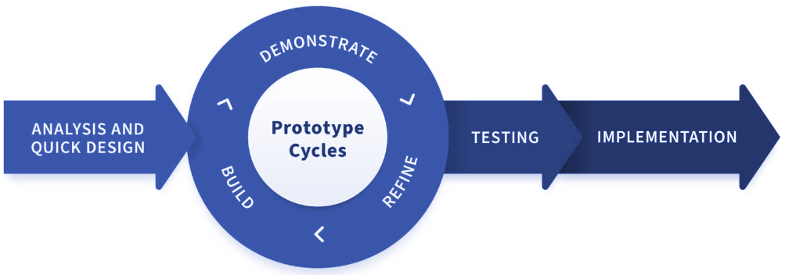

**Figure 22.** RAD software development methodology model.

There were many SDLC models to be used for software development, each with their own strengths and weaknesses, but the Rapid Application Development (RAD) model was chosen for the development of this study.

According to Dopico (2019), RAD was a form of agile software development methodology that prioritizes rapid prototype releases and iterations. As a result, it could deliver developed software and make changes quickly while aiming to deliver a product that more closely fits the needs of the user through consistent testing and tweaking. The process of RAD as shown in the figure above consisted of four (4) main phases that steer the development process. The processes of the researchers during the phases of analysis and quick design, prototype cycles, testing, and implementation, were discussed in the following:

***Analysis and Quick Design***

In this phase, the researchers defined the requirements, scope, and goals of the web application, Dinder. Through intensive brainstorming and research from existing matching applications, the researchers were able to determine the features developed. With the requirements set out, the researchers then set up meetings in order to determine the scope and goals of the study which included the timeline of the development.

***Prototype Cycles***

The researchers started building out the prototype during this phase. Due to the lengthy process of gathering cross breed dog images for the online application, this phase took quite some time. This phase continued until the researchers determined that the product was ready to be finalized.

***Testing***

Once the prototype had met its goals, the researchers then tested the working prototype themselves since they did not have a client. Whenever someone would give out a suggestion for what needed to be improved for the prototype or found an error in its use, it would immediately be carried out or fixed in the previous phase. This back and forth between the prototype building and testing were repeated until the prototype no longer encountered errors or bugs.

***Implementation***

The researchers accomplished the prototype in this phase. After this phase, the researchers would then be able to present the prototype.

## Prototype Actual Testing

Once the prototype had been developed, actual testing was conducted to assess how reliable and logical the predictions and image display of offsprings were respectively. The assessment of the actual testing was based purely on the observations of the researchers of this study. The image recognition and offspring image display actual testing were discussed in the following:

***Image Recognition Actual Testing***

This particular testing aimed to assess the reliability of the predictions of breed, coat color, and type image classifiers. Each model was tested with an image input for every dog breed within the scope of this study. The image inputs were taken from Facebook posts of random users to imitate a real person’s dog image.

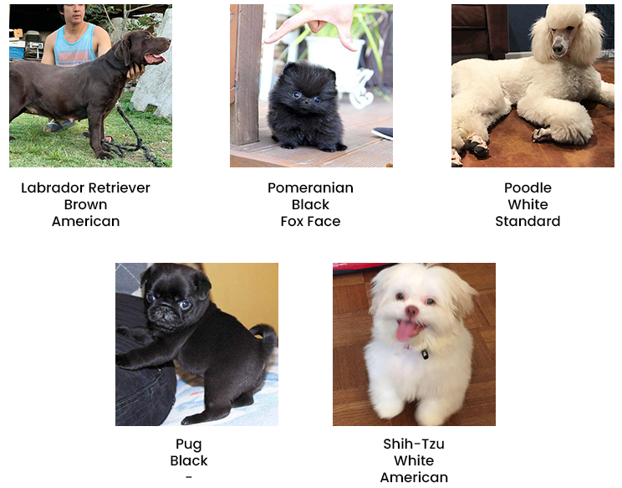

**Figure 23.** Image recognition actual testing images.

Based on the figure above, each breed had their true labels prepared before conducting the actual testing. Upon conducting this actual testing, predicted labels would have been assessed.

***Offspring Image Display Actual Testing***

On the other hand, this particular testing aimed to assess the logicalness of possible offspring images displayed. The researchers conducted this by purposely matching two pairs of dogs with certain breeds and coat colors, and then objectively observing if their offsprings would make sense. Similarly, the image inputs were taken from Facebook posts of random users to imitate a real person’s dog image.

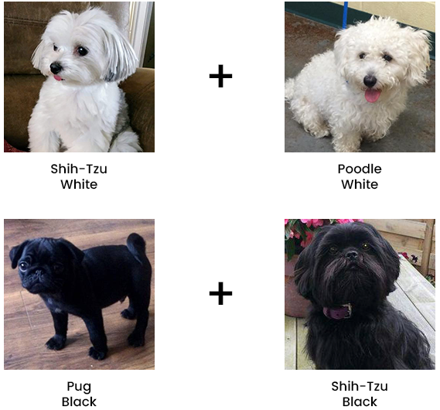

**Figure 24.** Offspring image display actual testing images.

Upon conducting this actual testing, the possible offspring images from the breeds and coat colors based on the figure above would be assessed.

## Software Used

Various software were used in order to develop the prototype and test the algorithms for this study. The software used for this study were discussed in the following:

***Google Colab***

Google Colaboratory, or simply “Colab”, was a browser-based Python development environment powered by Google Cloud. It was well renowned for being effective for tasks involving deep learning with TensorFlow, which required lots of computational power, as it allowed the use of Google’s GPU. This software was utilized in the overall data model generation from image preprocessing to training and testing the deep learning models developed.

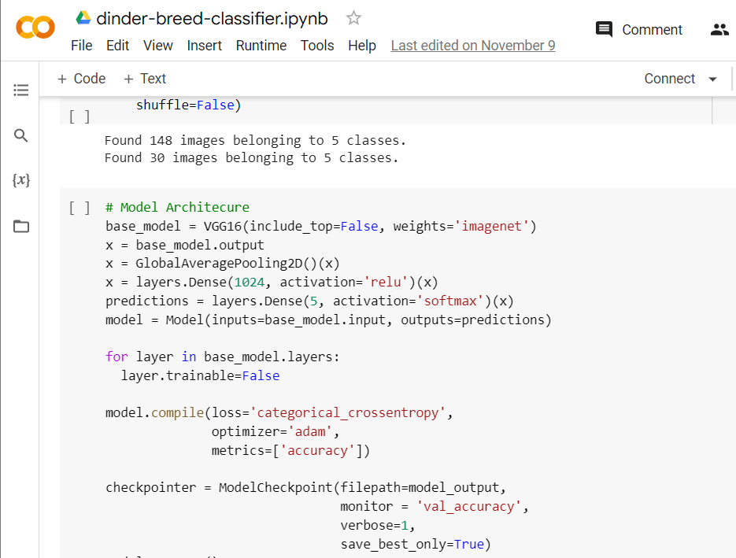

**Figure 25.** Screenshot of the Google Colab development environment.

A screenshot of the Google Colab environment with lines of codes written by the researchers of this study was shown in the figure above. Google Colab was chosen as one of the software for development, since it was more practical and had pre-installed important libraries for deep learning tasks, such as Keras from TensorFlow which had the pre-trained convolutional neural network models ready to be imported. Moreover, as aforementioned, Google Colab allowed users to use Google’s GPU. This would allow the training time for models to be faster.

***Visual Studio Code***

Visual Studio Code, also commonly called “VS Code”, was a lightning fast source code editor that runs on desktop computers. Like almost all Integrated Development Environments (IDEs), it had support for almost all programming languages, especially the Python programming language that was used by the researchers in this study. The researchers used this software in order to develop and test the prototype, Dinder.

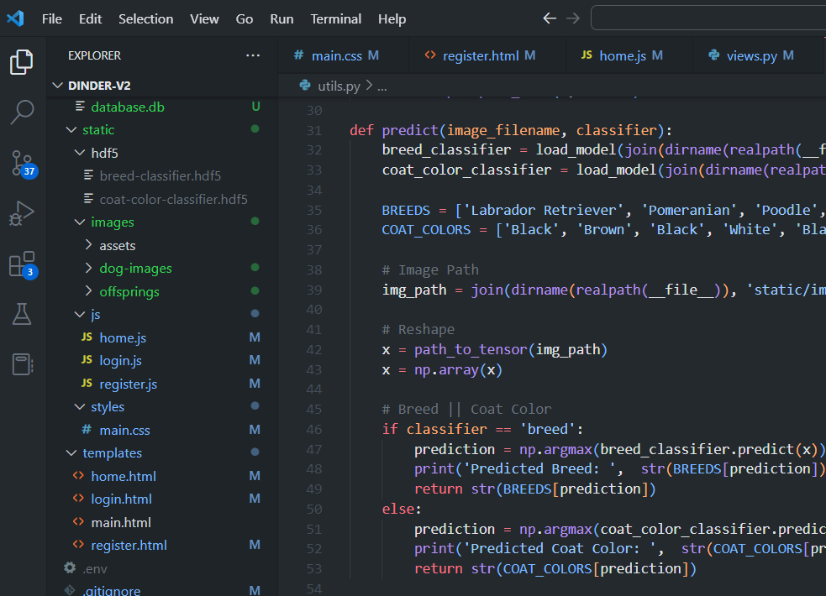

**Figure 26.** Screenshot of the Visual Studio Code IDE.

The figure above shows a screenshot of the VS Code source code editor with a piece of code written by the researchers for the prototype. It was used by the researchers for web development since it was less complex than others available on the market, and it came with tons of extensions to browse and install.

**CHAPTER IV**

# RESULTS AND DISCUSSION

This chapter would discuss the results of the study in correlation to the research objectives established by the researchers. It included the design and development of the prototype, the results of the evaluation of transfer learning-based models, and the actual testing of the developed as they were outlined in the first chapter.

## System Overview

The developed prototype of the study entitled, “Dinder: A Dog Matching Web-Based Application Using Convolutional Neural Networks with EfficientNetB0 Transfer Learning,” was a web-based application that served as a novel method to the challenges of the existing methods in searching for dog partners. The application had an image recognition for prediction of breeds and coat colors of dogs and an offspring display to show possible offsprings from dogs that have matched. Dog matching was simpler since dog owners would be able to filter out irrelevant information, such as dogs far from their preference. It was able to filter out information based primarily on the breeds and coat colors, as well other information, such as gender, location, etc. The application could potentially provide an efficient and effective method for dog matching that could result in the significant reduction of time and effort taken by dog owners searching for partners for their dogs.

## RESEARCH OBJECTIVE 1: To design and develop a dog matching web application prototype with image recognition of breeds, coat colors, and types as well as image display of offsprings for Labrador Retrievers, Pomeranians, Poodles, Pugs, and Shih-Tzus.

In order to achieve the first objective of the study which was to design and develop the application, Dinder, online research was utilized as the initial stage in the Rapid Application Development (RAD) software methodology as indicated in the third chapter of the study to identify the necessary features to develop. The screenshots of the developed prototype were shown in the following:

**Login Page**

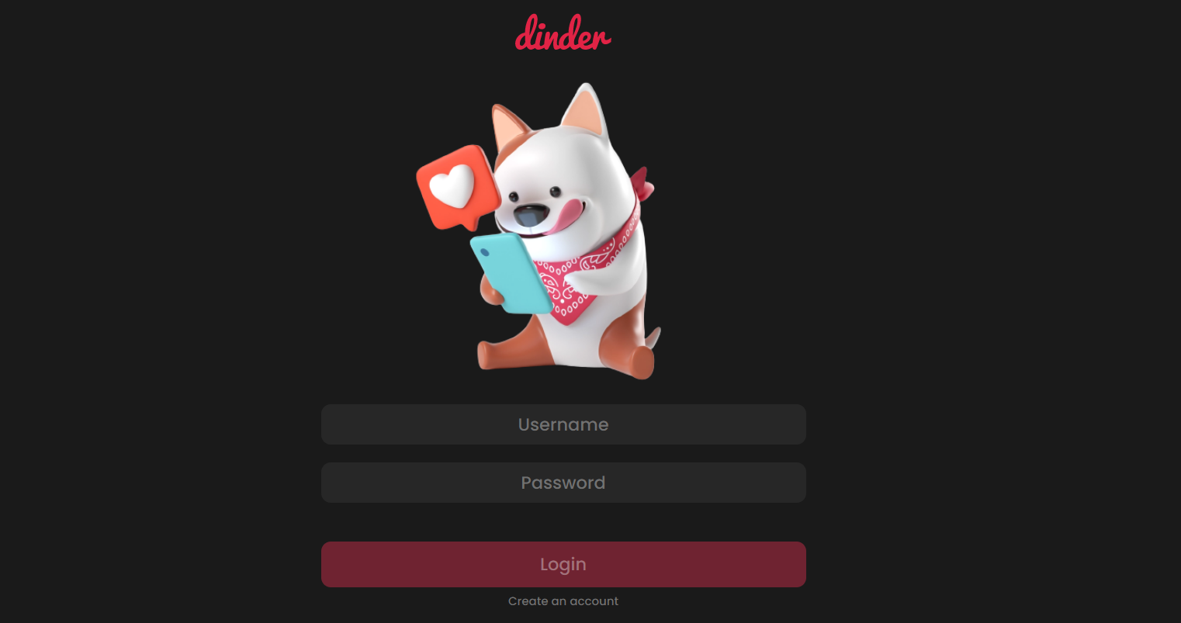

**Figure 27.** Login page.

The index route of the web application was the login page. In this page, users were required to login to enter Dinder. Otherwise, they would have to create an account by clicking on “Create an account.”

**Create Account Pages**

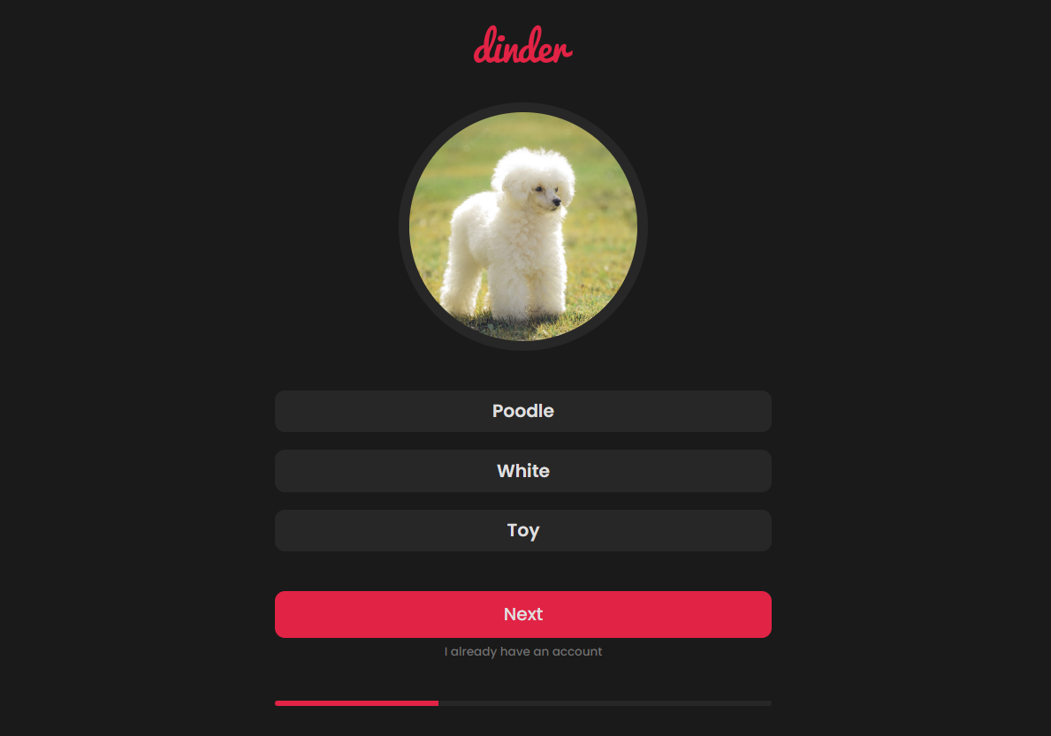

**Figure 28.** Create account page 1.

The create account page consists of 3 sub pages. Its first part was shown in the figure above, where the image input was predicted to be a white toy poodle. If a user already had an account, by simply clicking on “I already have an account,” the user would be redirected back to the login page.

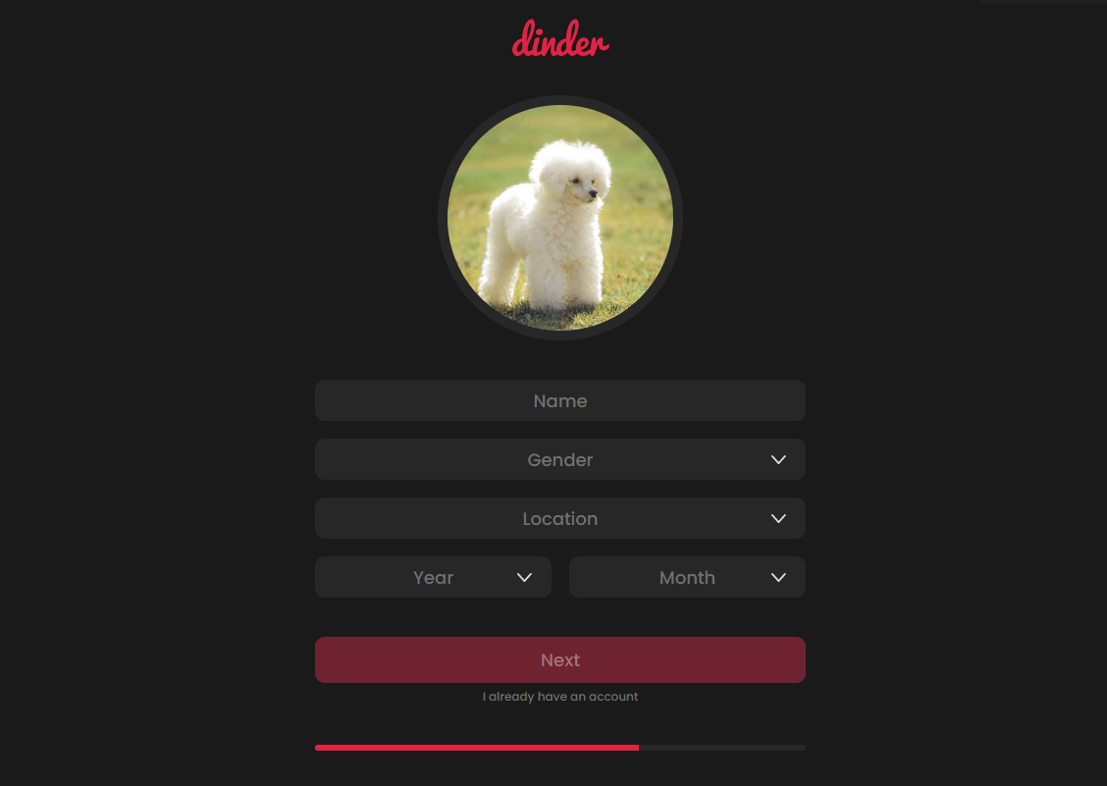

**Figure 29.** Create account page 2.

The second page of the create account pages was shown in the figure above. In this part, the name, gender, location, and age in year and month values needed to be taken from the user as inputs.

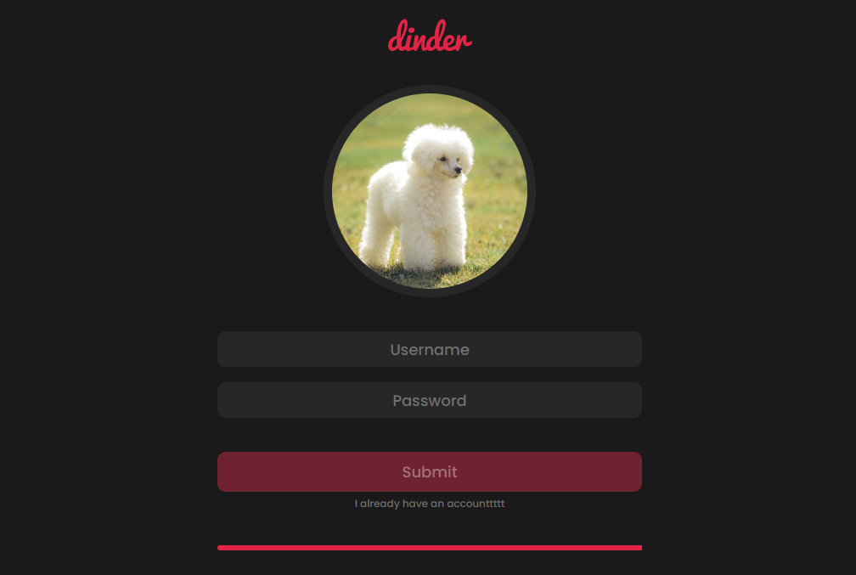

**Figure 30.** Create account page 3.

On the last page of the create account pages, the username and password of the user would need to be taken as input. In the figure above, the values for the input fields were given values. When the user clicks on “Submit,” the user would be registered and would be redirected back to the login page.

**Home Page**

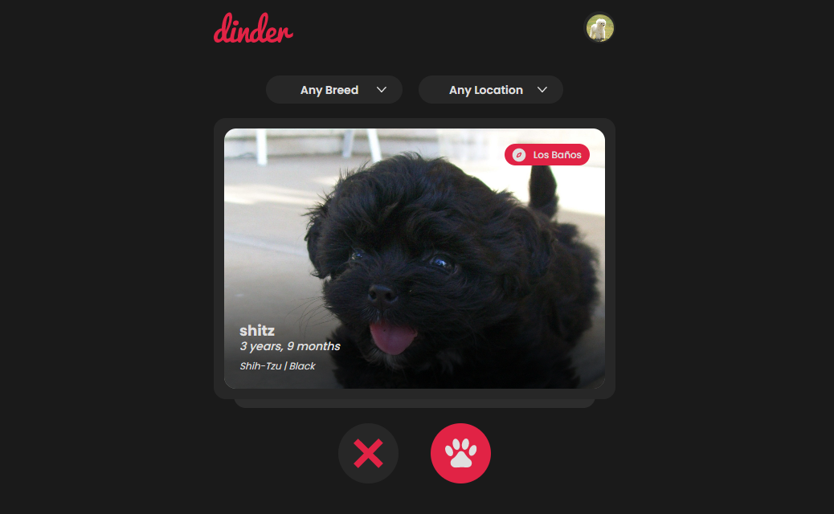

**Figure 31.** Home page.

The home page of the prototype was shown in the figure above. The other dog users registered could be seen on the home page, wherein the current user would be able to choose whether to like or reject the dog shown. Moreover, the current user would be able to filter the breed and locations.

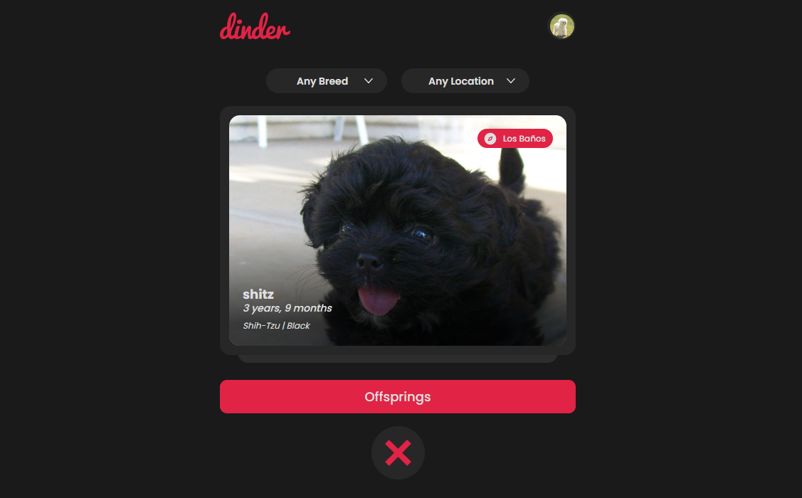

**Figure 32.** Offsprings button option.

Upon clicking the like button, the current user would be able to choose whether to view the possible offspring images by clicking “Offsprings” or reject the dog shown.

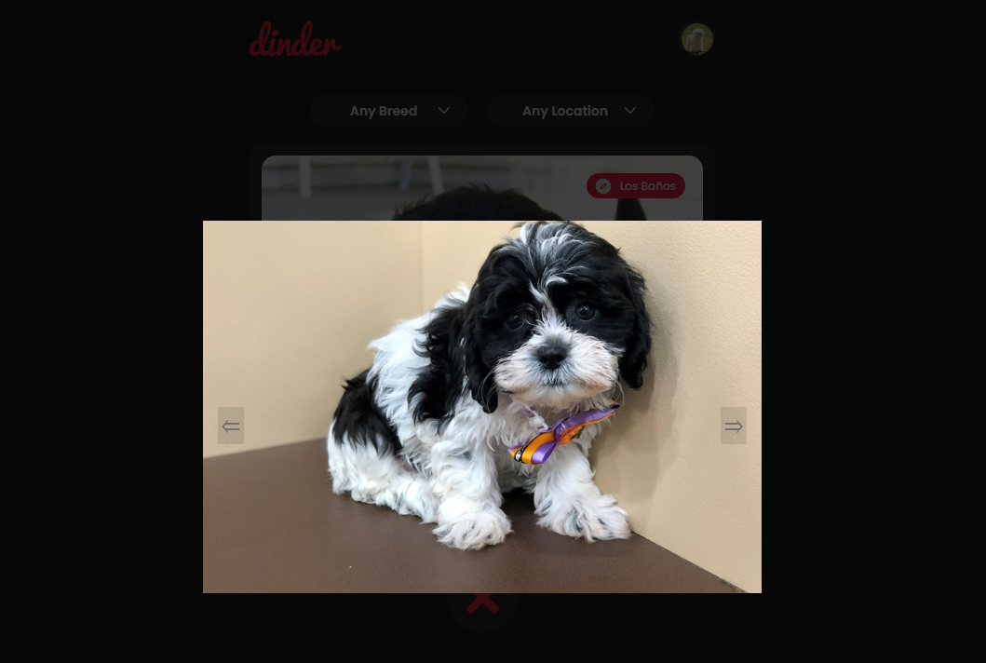

**Figure 33.** Offspring images display.

Upon clicking “Offsprings,” the current user would be able to view the possible offspring images of his/her dog should they ever breed with the dog shown.

## RESEARCH OBJECTIVE 2: To conduct model evaluation based on the accuracy, precision, recall, and F1-score of pre-trained CNN models, ResNet50, VGG16, and EfficientNetB0, with distinct numbers of parameters, to determine which transfer learning model to integrate.

To achieve the second objective of the study, the researchers evaluated the pre-trained models, ResNet50, VGG16, and EfficientNetB0 with different numbers of parameters. Each pre-trained models’ number of parameters were identified by the researchers upon observation from the Keras library API (*Keras Applications,* n.d.). The pre-trained models were evaluated based on their accuracy, precision, recall, and F1-score. This evaluation served as the basis for the selection of the pre-trained models to integrate for the transfer learning-based models.

**Table 6*.***Parameters of the pre-trained models.

|  |  |
| --- | --- |
| **PRE-TRAINED MODEL** | **PARAMETERS** |
| ResNet50 | 25.6M |
| VGG16 | 138.4M |
| EfficientNetB0 | 5.3M |

The table above summarized the analysis of the algorithms regarding their numbers of parameters, where ResNet50 had 25.6M parameters, VGG16 had 138.4M, and EfficientNetB0 had 5.3M. This showed that VGG16 had the most number of parameters, ResNet50 had the second highest number of parameters, and EfficientNetB0 had the least number of parameters.

**Table 7*.***Model evaluation results of the pre-trained models.

|  |  |  |  |  |
| --- | --- | --- | --- | --- |
| **PRE-TRAINED MODEL** | **ACCURACY** | **PRECISION** | **RECALL** | **F1-SCORE** |
| ResNet50 | 86.67% | 89.29% | 83.33% | 86.21% |
| VGG16 | 83.33% | 83.33% | 83.33% | 83.33% |
| EfficientNetB0 | **100.00%** | **100.00%** | **100.00%** | **100.00%** |

Based upon the results of the model evaluation, it could be seen that the EfficientNetB0 pre-trained convolutional neural network (CNN) model clearly outperformed the rest of the pre-trained models across all metrics.

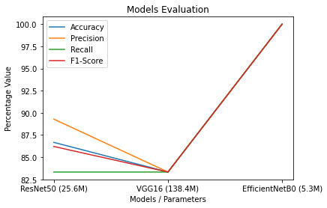

**Figure 34.** Models evaluation graph.

The model evaluation showed that the integration of the simplest pre-trained model was best. The figure above completely summarized the model evaluation conducted. Therefore, it was concluded that the best approach for dealing with small datasets was to use a simple neural network for better performance. The pre-trained model determined by the researchers was EfficientNetB0.

## RESEARCH OBJECTIVE 3: To examine the performance of the models developed integrated into the prototype through actual testing.

In order to achieve the last specific objective of the study, prototype actual testing was conducted. The predictions of the image classifiers were assessed based on their reliability. Moreover, the offspring image displays were assessed based on their logicalness. Each assessment was discussed in the following:

***Image Recognition Actual Testing***

In order to examine the reliability of the predictions of the image classifiers, an image input for each breed was fed into the prototype through a series of tests. Their true labels were prepared beforehand. If the prediction was true, it was marked with a check. On the other hand, if it was false it was marked with a cross.

**Table 8*.***Actual testing results of image recognition.

|  |  |  |
| --- | --- | --- |
| **BREED** | **COAT COLOR** | **TYPE** |
| Labrador Retriever ✔ | Brown ✔ | American ✔ |
| Pomeranian ✔ | Black ✔ | Fox Face ✔ |
| Poodle ✔ | White ✔ | Standard ✔ |
| Pug ✔ | Black ✔ | - |
| Shih-Tzu ✔ | White ✔ | American ✔ |

All the results of the series of tests were correct. Therefore, it could be concluded that the image recognition classifiers were highly reliable.

***Offspring Image Display Actual Testing***

In order to examine the logicalness of possible offspring images displayed, a series of tests wherein two pairs of dogs with certain breeds and coat colors were matched purposely. Then, the images displayed were objectively observed on whether their offsprings would make sense.

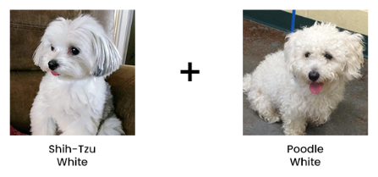

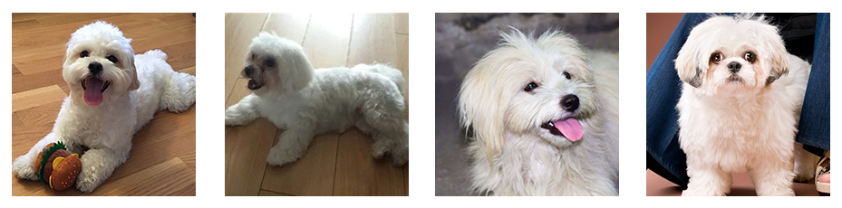

**Figure 35.** White shih-tzu and white poodle possible offspring images.

The possible offspring images for white shih-tzu and white poodle returned by the prototype seemed logical upon observation.

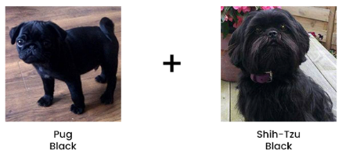

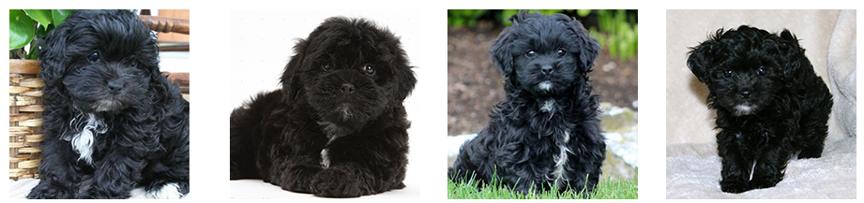

**Figure 36.** Black pug and black shih-tzu possible offspring images.

The possible offspring images for black pug and black shih-tzu returned by the prototype seemed logical upon observation.

**CHAPTER V**

# SUMMARY, CONCLUSIONS, AND RECOMMENDATIONS

This chapter would briefly discuss the summary of findings, conclusions, and recommendations for future researchers that were reached by this study’s researchers after conducting their research.

## Summary

The study aimed to design and develop a dog matching web application prototype as well as image display of offsprings for Labrador Retrievers, Pomeranians, Poodles, Pugs, and Shih-Tzus. During the course of the study, the researchers discovered that in most of the studies, the ResNet50 pre-trained model always outperformed the other pre-trained models with the large datasets the other researchers used. Moreover, through the intense reading of various literature regarding deep learning, particularly artificial neural networks, the researchers learned that there was more to Artificial Intelligence (AI) than simply focusing on machine learning algorithms. Most importantly, the researchers discovered that one cannot simply apply any pre-trained models to their model just because it was said to be the most accurate several factors, especially the size of the dataset affect accuracy.

## Conclusions

Based on the findings of the study from the objectives, the researchers have reached the following conclusions and generalizations:

1. In developing the prototype, the researchers discovered that the use of Flask as the backend framework for the prototype fit very well with the RAD software development methodology’s quick process of development.
2. The researchers discovered that based on Chapter 4, the integration of the parameters or weights of EfficientNetB0 in a CNN model resulted as the best-performing, since the small datasets adapted better with the simpler convolutional neural network with 5.3 million parameters as opposed to other pre-trained models of tens of millions of parameters.
3. Upon conducting the prototype actual testing, the researchers found that once the predictions of breeds and coat colors were correct, the following test cases would be correct as well.

## Recommendations

Based on the conclusions, the researchers have reached the following recommendations:

1. The researchers recommend a full development of the prototype with the prototype being open-sourced on a GitHub repository.
2. The researchers recommend the use of simpler pre-trained models that have significantly less parameters or weights for simple datasets that have few images.
3. The researchers recommend the input of blurry or pixelated images to fully test the prototype.

# REFERENCES

Agrawal, S. K. (2021, July 20). *Metrics to Evaluate your Classification Model to take the right decisions.* Analytics Vidhya. https://www.analyticsvidhya.com/blog/2021/07/metrics-to-evaluate-your-classification-model-to-take-the-right-decisions/

Ahmed, T., & Sabab, N. H. N. (2022). Classification and Understanding of Cloud Structures via Satellite Images with EfficientUNet. *SN Computer Science, 3*(1). https://doi.org/10.1007/s42979-021-00981-2

Alhichri, H., Alswayed, A. S., Bazi, Y., Ammour, N., & Alajlan, N. A. (2021). Classification of Remote Sensing Images Using EfficientNet-B3 CNN Model With Attention. *IEEE Access*, *9*, 14078–14094. https://doi.org/10.1109/access.2021.3051085

Anthes, E. (2022, December 16). *How far should we go in shaping animals for aesthetic pleasure? | Aeon Essays*. Aeon. https://aeon.co/essays/how-far-should-we-go-in-shaping-animals-for-aesthetic-pleasure

Arc. (2018, December 25). *Convolutional Neural Network - Towards Data Science.* Medium. https://towardsdatascience.com/convolutional-neural-network-17fb77e76c05

Archer, J. (1997). Why do people love their pets? *Evolution and Human Behavior, 18*(4), 237–259. https://doi.org/10.1016/s0162-3095(99)80001-4

Ayanzadeh, A., & Vahidnia, S. (2018). Modified Deep Neural Networks for Dog Breeds Identification. https://doi.org/10.20944/preprints201812.0232.v1

Biswas, S. (2019). The Benefits of Pets for Human Health. *Psychology and Behavioral Science*, *13*(2). https://doi.org/10.19080/PBSIJ.2019.13.555862

Boden, M. A. (1996). *Artificial intelligence*. Elsevier.

Boesch, G. (2021, December 5). *VGG Very Deep Convolutional Networks (VGGNet) – What you need to know.* viso.ai. https://viso.ai/deep-learning/vgg-very-deep-convolutional-networks/

Boteju, W., Herath, H., Peiris, M., Wathsala, A., Samarasinghe, P., & Weerasinghe, L. (2020). Deep Learning Based Dog Behavioural Monitoring System. *2020 3rd International Conference on Intelligent Sustainable Systems (ICISS).* https://doi.org/10.1109/iciss49785.2020.9315983

Co, R. (2022, March 14). *What are the Popular Dog Breeds in the Philippines?* Tatler Asia. https://www.tatlerasia.com/power-purpose/others/most-popular-dog-breeds-in-the-philippines

Brownlee, J. (2020). *Train-Test Split for Evaluating Machine Learning Algorithms*. Machine Learning Mastery. https://machinelearningmastery.com/train-test-split-for-evaluating-machine-learning-algorithms/

Cohut, M., PhD. (2018, August 26). *Dogs: Our best friends in sickness and in health*. https://www.medicalnewstoday.com/articles/322868

Deng, J., Dong, W., Socher, R., Li, L. J., Kai Li, & Li Fei-Fei. (2009). ImageNet: A large-scale hierarchical image database. *2009 IEEE Conference on Computer Vision and Pattern Recognition*. https://doi.org/10.1109/cvpr.2009.5206848

Dickson, B. (2020, January 6). *What are convolutional neural networks (CNN)?* TechTalks. https://bdtechtalks.com/2020/01/06/convolutional-neural-networks-cnn-convnets/

Donges, N. (2022). *What Is Transfer Learning? Exploring the Popular Deep Learning Approach.* Built In. https://builtin.com/data-science/transfer-learning

Dopico, A. (2019). What is rapid application development approach? Janet. https://janetpanic.com/what-is-rapid-application developmentapproach/#Who_uses_RAD

Dwivedi, P. (2019, January 5). *Understanding and Coding a ResNet in Keras - Towards Data Science.* Medium. https://towardsdatascience.com/understanding-and-coding-a-resnet-in-keras-446d7ff84d33

Fernández, A., García, S., Galar, M., Prati, R. C., Krawczyk, B., & Herrera, F. (2018). *Learning from Imbalanced Data Sets.* https://doi.org/10.1007/978-3-319-98074-4

Fong, S., & Biuk-Aghai, R. P. (2009, December). An Automated University Admission Recommender System for Secondary School Students. *The 6th International Conference on Information Technology and Applications*.

Fu, G., Jin, Y., Sun, S., Yuan, Z., & Butler, D. (2022). The role of deep learning in urban water management: A critical review. *Water Research*, *223*, 118973. https://doi.org/10.1016/j.watres.2022.118973

Gour, R. (2019, February 7). *Train and Test Set in Python Machine Learning — How to Split.* Medium. https://medium.com/@rinu.gour123/train-and-test-set-in-python-machine-learning-how-to-split-58029a0d657b

He, K., Zhang, X., Ren, S., & Sun, J. (2016). Deep Residual Learning for Image Recognition. *2016 IEEE Conference on Computer Vision and Pattern Recognition (CVPR)*. https://doi.org/10.1109/cvpr.2016.90

Huang, Y., Cheng, Y., Bapna, A., Firat, O., Chen, D., Chen, M. X., Lee, H., Ngiam, J., Le, Q. V., Wu, Y., & Chen, Z. (2019). GPipe: Efficient Training of Giant Neural Networks using Pipeline Parallelism. Neural Information Processing Systems, 32, 103–112.

Iqbal, S. Z., & Idrees, M. (2017). Z-SDLC model: a new model for software development life cycle (SDLC). *International Journal of Engineering and Advanced Research Technology (IJEART)*, *3*(2), 8.

Jeong, J. (2018, December 25). *The Most Intuitive and Easiest Guide for Convolutional Neural Network.* Medium. https://towardsdatascience.com/the-most-intuitive-and-easiest-guide-for-convolutional-neural-network-3607be47480

Ji, L., Fu, C., & Sun, W. (2021). Soft Fault Diagnosis of Analog Circuits Based on a ResNet With Circuit Spectrum Map. *IEEE Transactions on Circuits and Systems I: Regular Papers, 68*(7), 2841–2849. https://doi.org/10.1109/tcsi.2021.3076282

Karthick, R. (2018). DEEP LEARNING FOR AGE GROUP CLASSIFICATION SYSTEM. *International Journal of Advances in Signal and Image Sciences, 4*(2), 16. https://doi.org/10.29284/ijasis.4.2.2018.16-22

Kavlakoglu, E. (2020, May 27). *AI vs. Machine Learning vs. Deep Learning vs. Neural Networks: What’s the Difference?* IBM.https://www.ibm.com/cloud/blog/ai-vs-machine-learning-vs-deep-learning-vs-neural-networks

Keras Applications. (n.d.). https://keras.io/api/applications/

Kim, P. (2017). Convolutional Neural Network. *MATLAB Deep Learning*, 121–147. https://doi.org/10.1007/978-1-4842-2845-6_6

King, T., Marston, L. C., & Bennett, P. C. (2012). Breeding dogs for beauty and behaviour: Why scientists need to do more to develop valid and reliable behaviour assessments for dogs kept as companions. *Applied Animal Behaviour Science, 137*(1–2), 1–12. https://doi.org/10.1016/j.applanim.2011.11.016

Koehrsen, W. (2018, November 27). *Transfer Learning with Convolutional Neural Networks in PyTorch.* Medium. https://towardsdatascience.com/transfer-learning-with-convolutional-neural-networks-in-pytorch-dd09190245ce

Kumar, V. (2020). *Implementing EfficientNet: A Powerful Convolutional Neural Network.* Analytics India Magazine. https://analyticsindiamag.com/implementing-efficientnet-a-powerful-convolutional-neural-network/

LeCun, Y., Bengio, Y., & Hinton, G. (2015). Deep learning. *Nature, 521*(7553), 436–444. https://doi.org/10.1038/nature14539

Lin, M., Chen, Q., & Yan, S. (2013). Network in Network. *Neural and Evolutionary Computing*. https://doi.org/10.48550/arXiv.1312.4400

Ma, Y., & He, H. (Eds.). (2013). Imbalanced learning: foundations, algorithms, and applications. https://doi.org/10.1002/9781118646106.

Mahanta, J. (2017, July 10). *Introduction to Neural Networks, Advantages and Applications.* Medium.https://towardsdatascience.com/introduction-to-neural-networks-advantages-and-applications-96851bd1a207

Malik, F. (2019, May 21). *What Are Hidden Layers? - FinTechExplained.* Medium. https://medium.com/fintechexplained/what-are-hidden-layers-4f54f7328263

Maxwell. (2020, April 14). *How To Find a Mate for Your Dog – Online & Offline*. Breeding Business. https://breedingbusiness.com/finding-a-mate-for-your-dog/

Mehta, A. (2022, May 23). *A Comprehensive Guide To Types Of Neural Networks.* Digital Vidya. https://www.digitalvidya.com/blog/types-of-neural-networks/

Middleton, M. (2021, February 8). *Deep Learning vs. Machine Learning — What’s the Difference?* Flatiron School*.* https://flatironschool.com/blog/deep-learning-vs-machine-learning/

Mishra, M. (2020, August 27). *Convolutional Neural Networks, Explained - Towards Data Science.* Medium. https://towardsdatascience.com/convolutional-neural-networks-explained-9cc5188c4939

Mohseni-Dargah, M., Falahati, Z., Dabirmanesh, B., Nasrollahi, P., & Khajeh, K. (2022). Machine learning in surface plasmon resonance for environmental monitoring. *Artificial Intelligence and Data Science in Environmental Sensing*, 269–298. https://doi.org/10.1016/b978-0-323-90508-4.00012-5

Nelson, J. (2020, January 26). *Why pre-processing and augmentation matters for computer vision.* Roboflow Blog. https://blog.roboflow.com/why-preprocess-augment/

Oppermann, L., Boden, A., Hofmann, B., Prinz, W., & Decker, S. (2019). Beyond HCI and CSCW: Challenges and Useful Practices Towards a Human-Centred Vision of AI and IA. *Proceedings of the Halfway to the Future Symposium 2019*. https://doi.org/10.1145/3363384.3363481

Phung, & Rhee. (2019). A High-Accuracy Model Average Ensemble of Convolutional Neural Networks for Classification of Cloud Image Patches on Small Datasets. *Applied Sciences, 9*(21), 4500. https://doi.org/10.3390/app9214500

Rohini, G. (2021, September 23). *Everything you need to know about VGG16 - Great Learning.* Medium. https://medium.com/@mygreatlearning/everything-you-need-to-know-about-vgg16-7315defb5918

Rusk, N. (2016). Deep learning. *Nature Methods*, *13*(1), 35–35. https://doi.org/10.1038/nmeth.3707

Saha, S. (2018, November 16). *A Comprehensive Guide to Convolutional Neural Networks — the ELI5 way*. Medium. https://towardsdatascience.com/a-comprehensive-guide-to-convolutional-neural-networks-the-eli5-way-3bd2b1164a53a53

Sahoo, S. (2018, November 27). *Residual blocks — Building blocks of ResNet - Towards Data Science.* Medium. https://towardsdatascience.com/residual-blocks-building-blocks-of-resnet-fd90ca15d6ec

Sandler, M., Howard, A., Zhu, M., Zhmoginov, A., & Chen, L. C. (2018). MobileNetV2: Inverted Residuals and Linear Bottlenecks. *2018 IEEE/CVF Conference on Computer Vision and Pattern Recognition*. https://doi.org/10.1109/cvpr.2018.00474

Sarkar, A. (2021, May 8). *Understanding EfficientNet — The most powerful CNN architecture.* Medium. https://medium.com/mlearning-ai/understanding-efficientnet-the-most-powerful-cnn-architecture-eaeb40386fad

Saxena, S. (2021, March 12). *Image Augmentation Techniques for Training Deep Learning Models.* Analytics Vidhya. https://www.analyticsvidhya.com/blog/2021/03/image-augmentation-techniques-for-training-deep-learning-models/

Seb. S. (2021, December 5). *What is Pooling in a Convolutional Neural Network (CNN): Pooling Layers Explained - Programmathically. Programmathically - a Blog on Building.* Machine Learning Solutions. https://programmathically.com/what-is-pooling-in-a-convolutional-neural-network-cnn-pooling-layers-explained/

Seldon. (2021, June 29). *Transfer Learning for Machine Learning*. Seldon. https://www.seldon.io/transfer-learning

Serpa, Y. (2020, May 5). *Why Neural Networks Are Great For Computer Vision - Towards Data Science.* Medium.https://towardsdatascience.com/why-neural-networks-can-solve-simple-tasks-d268a770dbce

Shakhadri, S. (2021, June 7). *Build ResNet from Scratch With Python !* Analytics Vidhya. https://www.analyticsvidhya.com/blog/2021/06/build-resnet-from-scratch-with-python/

Simonyan, K., & Zisserman, A. (2014). Very Deep Convolutional Networks for Large-Scale Image Recognition. *Computer Vision and Pattern Recognition*. https://doi.org/10.48550/arXiv.1409.1556

Stock, J., & Cavey, T. (2021). Who’s a Good Boy? Reinforcing Canine Behavior using Machine Learning in Real-Time. *Computer Vision and Pattern Recognition*. https://doi.org/10.48550/arXiv.2101.02380

Suresh, A. (2020, November 17). *What is a confusion matrix? - Analytics Vidhya.* Medium. https://medium.com/analytics-vidhya/what-is-a-confusion-matrix-d1c0f8feda5

Szegedy, C., Wei Liu, Yangqing Jia, Sermanet, P., Reed, S., Anguelov, D., Erhan, D., Vanhoucke, V., & Rabinovich, A. (2015). Going deeper with convolutions. *2015 IEEE Conference on Computer Vision and Pattern Recognition (CVPR).* https://doi.org/10.1109/cvpr.2015.7298594

Tammina, S. (2019). Transfer learning using VGG-16 with Deep Convolutional Neural Network for Classifying Images. *International Journal of Scientific and Research Publications (IJSRP), 9*(10), p9420. https://doi.org/10.29322/ijsrp.9.10.2019.p9420

Tan, M., & Le, Q. (2019, May). EfficientNet: Rethinking Model Scaling for Convolutional Neural Networks. *International Conference on Machine Learning*, 6105–6114.

Theckedath, D., & Sedamkar, R. R. (2020). Detecting Affect States Using VGG16, ResNet50 and SE-ResNet50 Networks. *SN Computer Science, 1*(2). https://doi.org/10.1007/s42979-020-0114-9

Tyagi, N. (2020, April 24). *6 Major Branches of Artificial Intelligence (AI) | Analytics Steps.* https://www.analyticssteps.com/blogs/6-major-branches-artificial-intelligence-ai

Walden, L. (2020, July 27). *Dog breeding — the pros and cons*. PetProfessional. https://www.petprofessional.com.au/info-centre/dog-breeding-the-pros-and-cons/

Yamashita, R., Nishio, M., Do, R. K. G., & Togashi, K. (2018). Convolutional neural networks: an overview and application in radiology. *Insights Into Imaging*, *9*(4), 611–629. https://doi.org/10.1007/s13244-018-0639-9

Zoph, B., & Le, Q. V. (2016). Neural Architecture Search with Reinforcement Learning. *Machine Learning*. https://doi.org/10.48550/arXiv.1611.01578

# 

# 

# APPENDICES

## APPENDIX A

Technical Background

### Dataset Screenshots

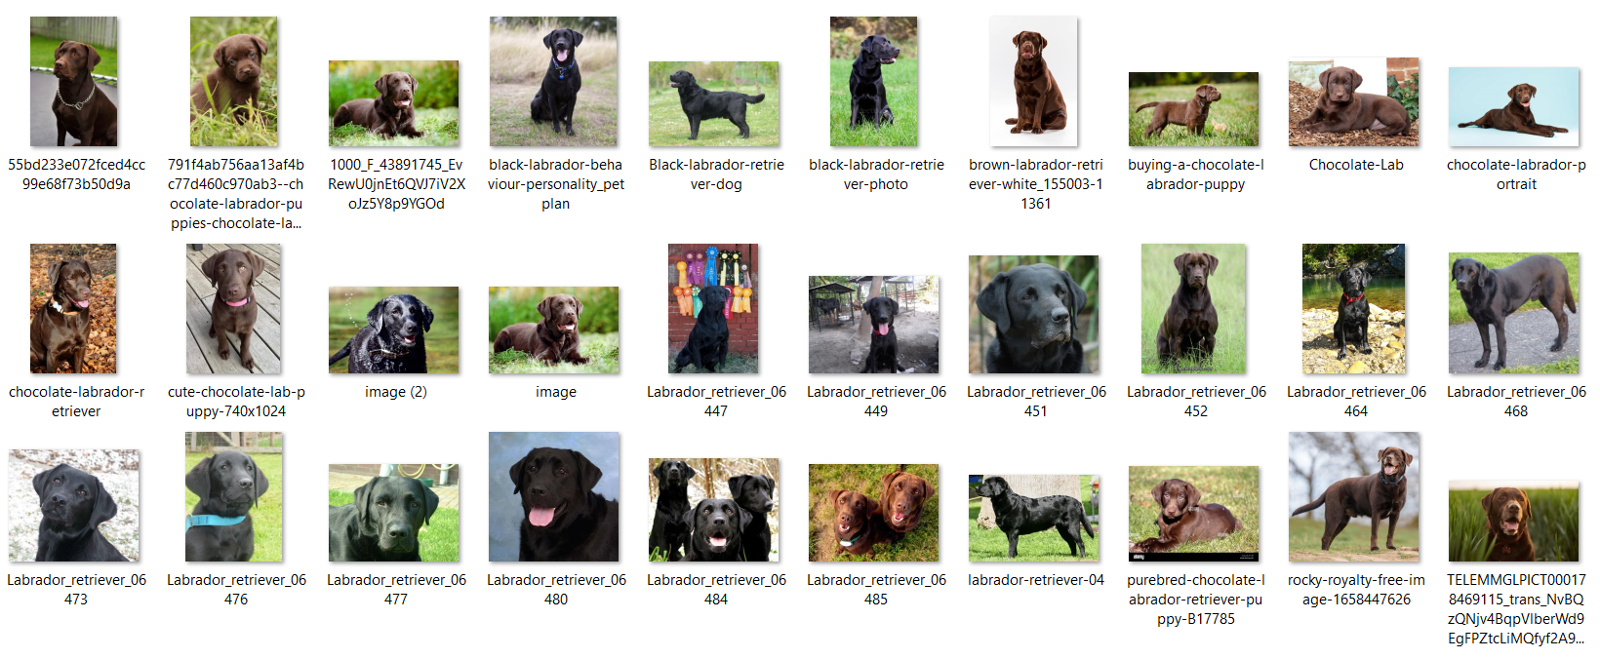

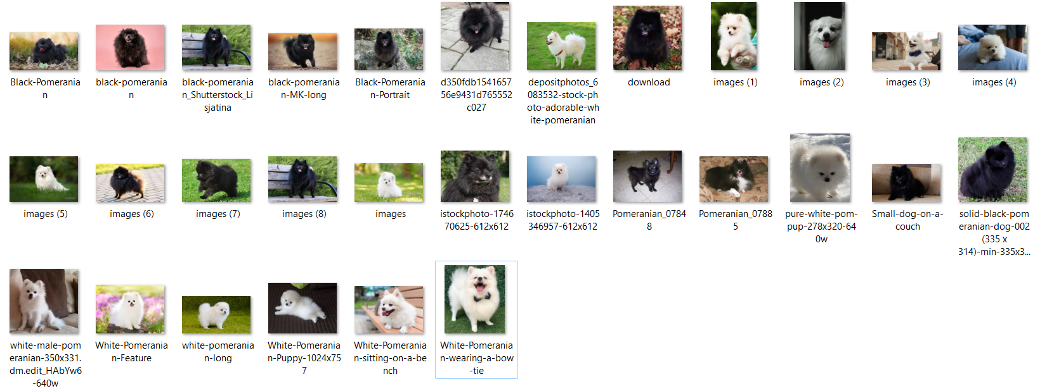

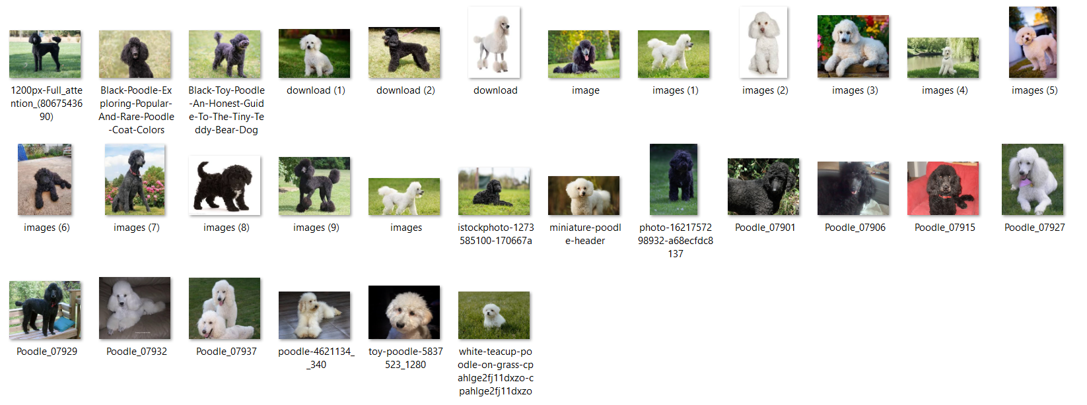

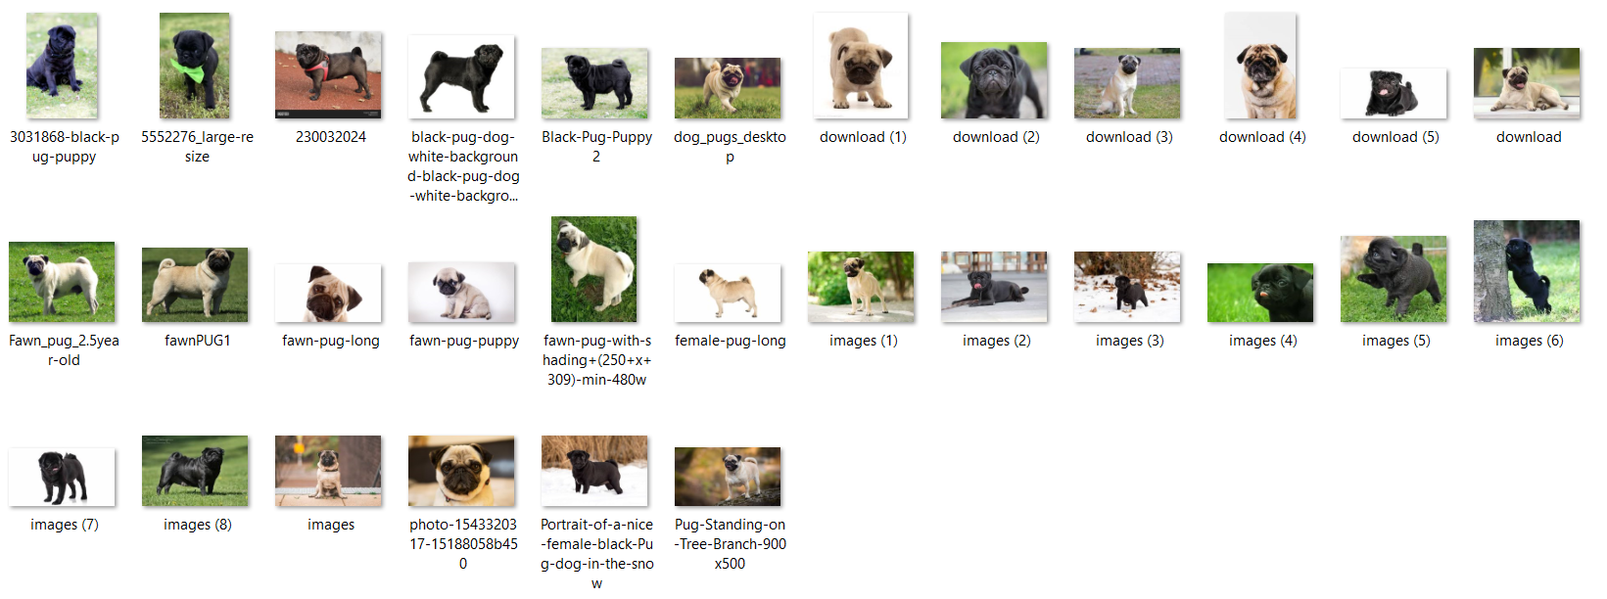

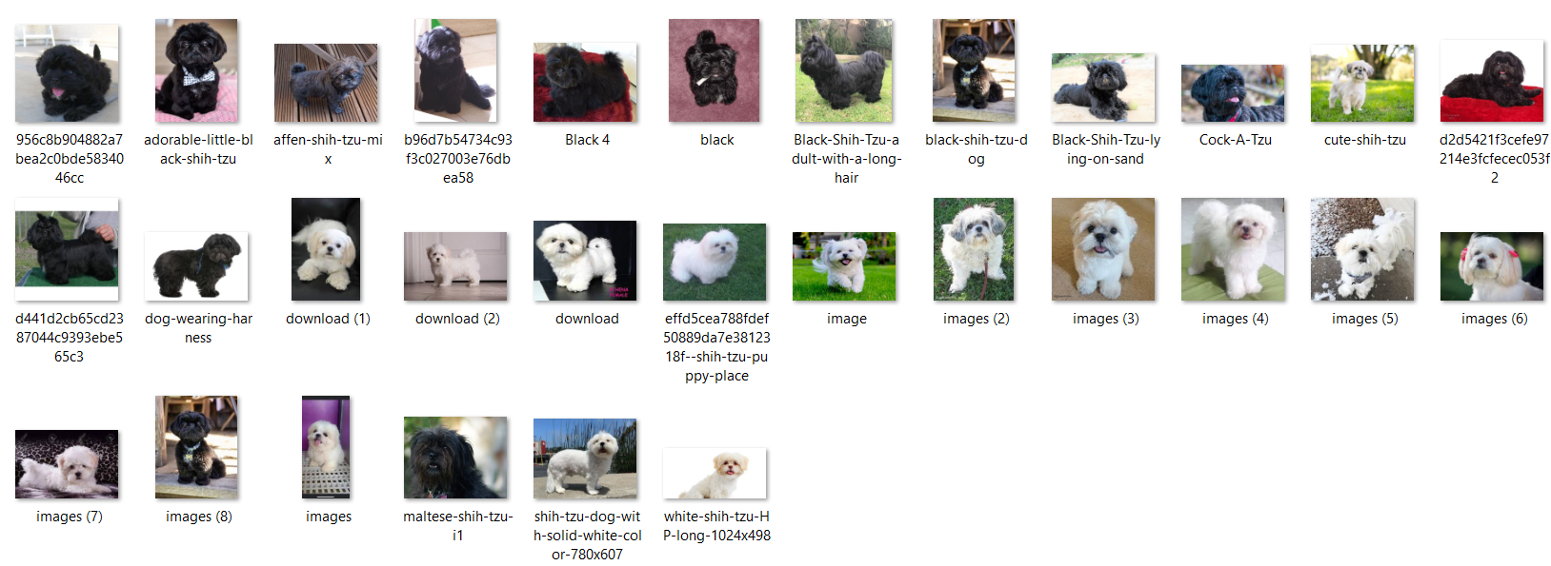

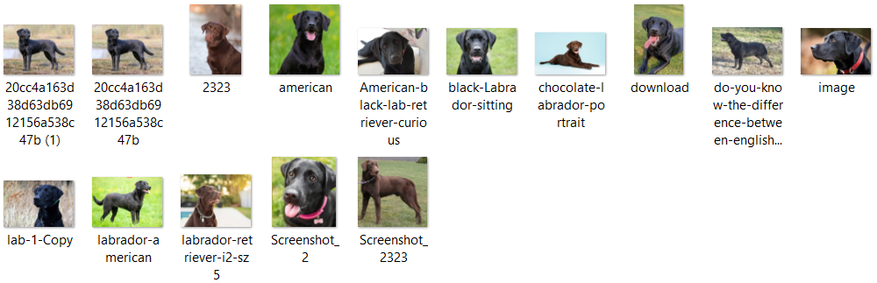

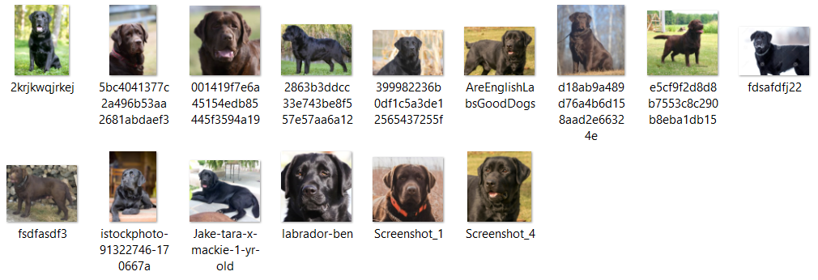

### Hardware and Software Resources

***Hardware***

* 1.00 TB Disk Storage
* 8.00 GB RAM
* Intel® Core™ i3-1115G4 Processor

***Software***

* Visual Studio Code 1.73.1
* Figma
* SQLite 2.2.0
* Google Colab
* Python 3.10.7
* Git 2.38.0

### 

### Application Dependencies

* absl-py==1.3.0
* aniso8601==9.0.1
* astunparse==1.6.3
* cachetools==5.2.0
* certifi==2022.9.24
* charset-normalizer==2.1.1
* click==8.1.3
* colorama==0.4.6
* contourpy==1.0.6
* cycler==0.11.0
* dataclasses==0.6
* Flask==2.2.2
* Flask-RESTful==0.3.9
* Flask-SQLAlchemy==3.0.2
* flatbuffers==22.10.26
* fonttools==4.38.0
* gast==0.5.3
* google-auth==2.14.0
* google-auth-oauthlib==0.4.6
* google-pasta==0.2.0
* greenlet==1.1.3.post0
* grpcio==1.50.0
* h5py==3.7.0
* idna==3.4
* itsdangerous==2.1.2
* Jinja2==3.1.2
* keras==2.8.0
* Keras-Preprocessing==1.1.2
* kiwisolver==1.4.4
* libclang==14.0.6
* Markdown==3.4.1
* MarkupSafe==2.1.1
* matplotlib==3.6.1
* numpy==1.23.4
* oauthlib==3.2.2
* opencv-python==4.6.0.66
* opt-einsum==3.3.0
* packaging==21.3
* Pillow==9.3.0
* protobuf==3.20.1
* pyasn1==0.4.8
* pyasn1-modules==0.2.8
* pyparsing==3.0.9
* python-dateutil==2.8.2
* python-dotenv==0.21.0
* pytz==2022.6
* requests==2.28.1
* requests-oauthlib==1.3.1
* rsa==4.9
* six==1.16.0
* SQLAlchemy==1.4.42
* tensorboard==2.8.0
* tensorboard-data-server==0.6.1
* tensorboard-plugin-wit==1.8.1
* tensorflow==2.8.0
* tensorflow-io-gcs-filesystem==0.27.0
* termcolor==2.1.0
* tf-estimator-nightly==2.8.0.dev2021122109
* typing_extensions==4.4.0
* urllib3==1.26.12
* Werkzeug==2.2.2
* wrapt==1.14.1

## 

## APPENDIX B

Communication Letter & Forms

### 

### 

### ISO Forms

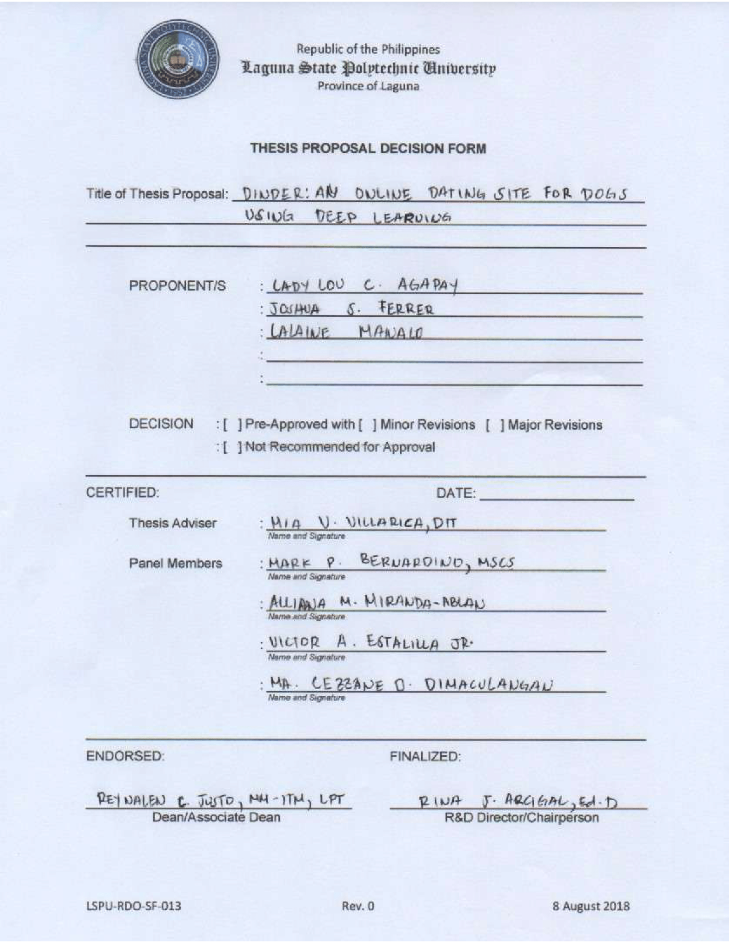













### 

### Defense Rating Sheets



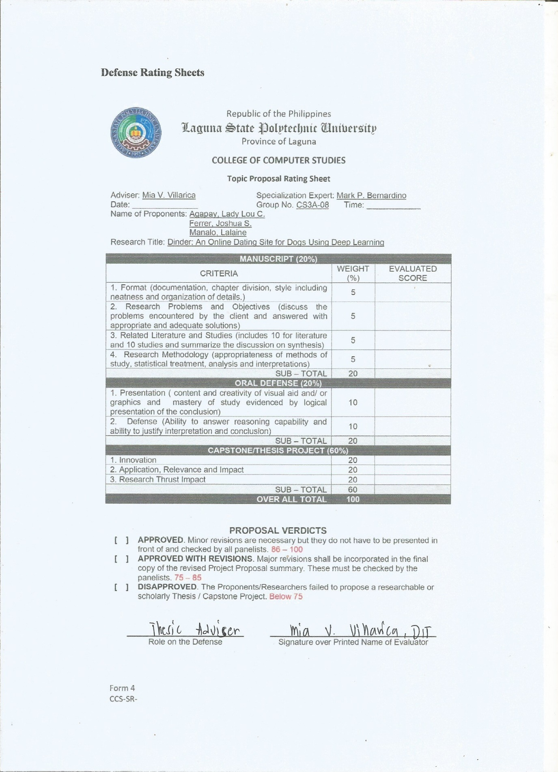







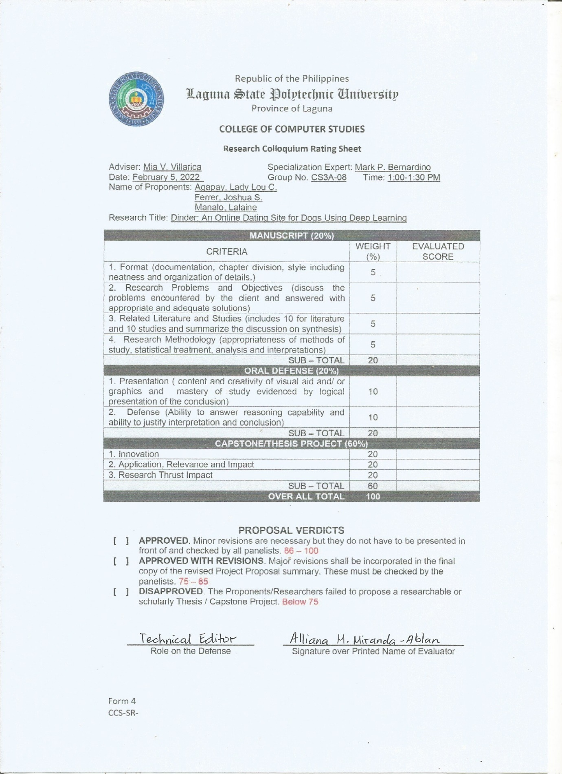

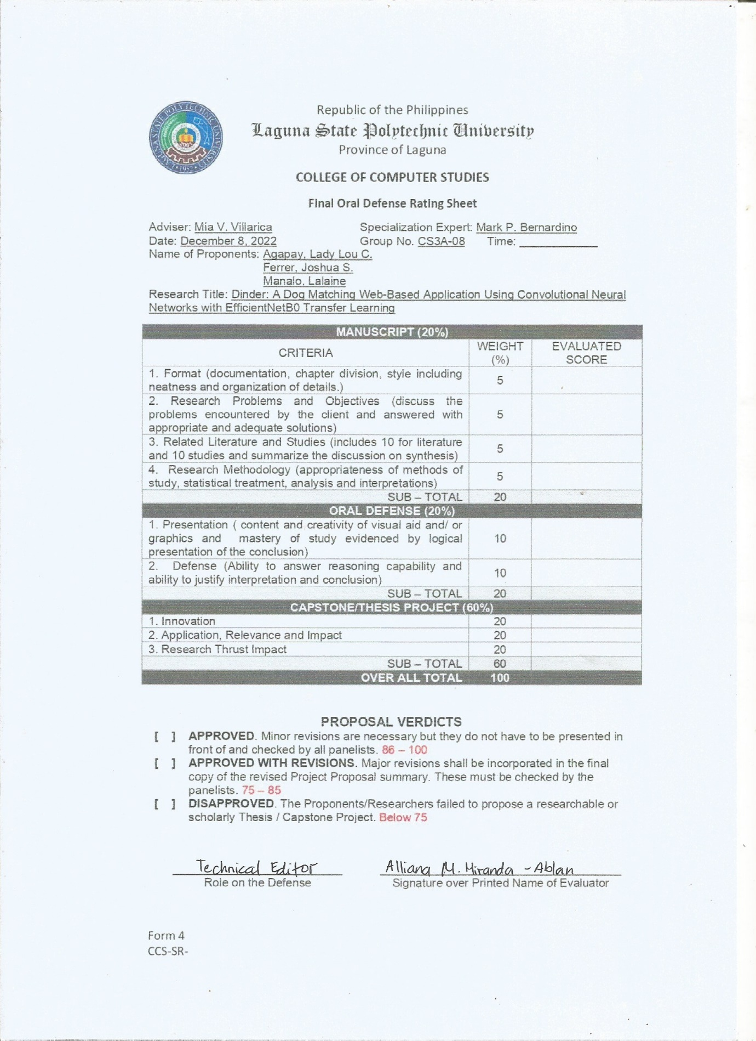



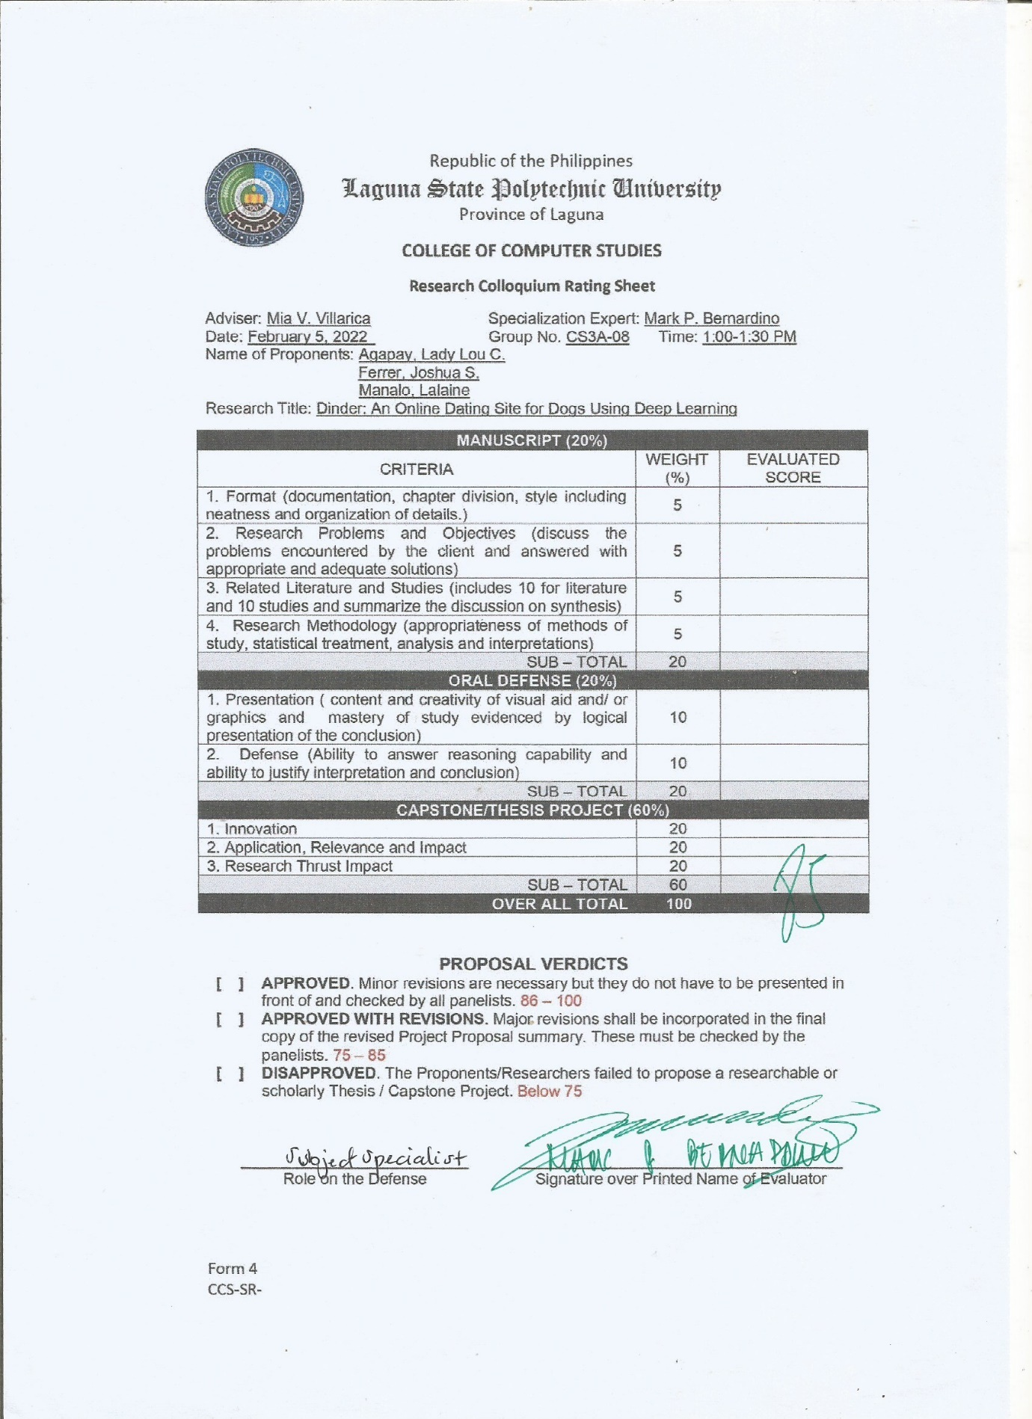



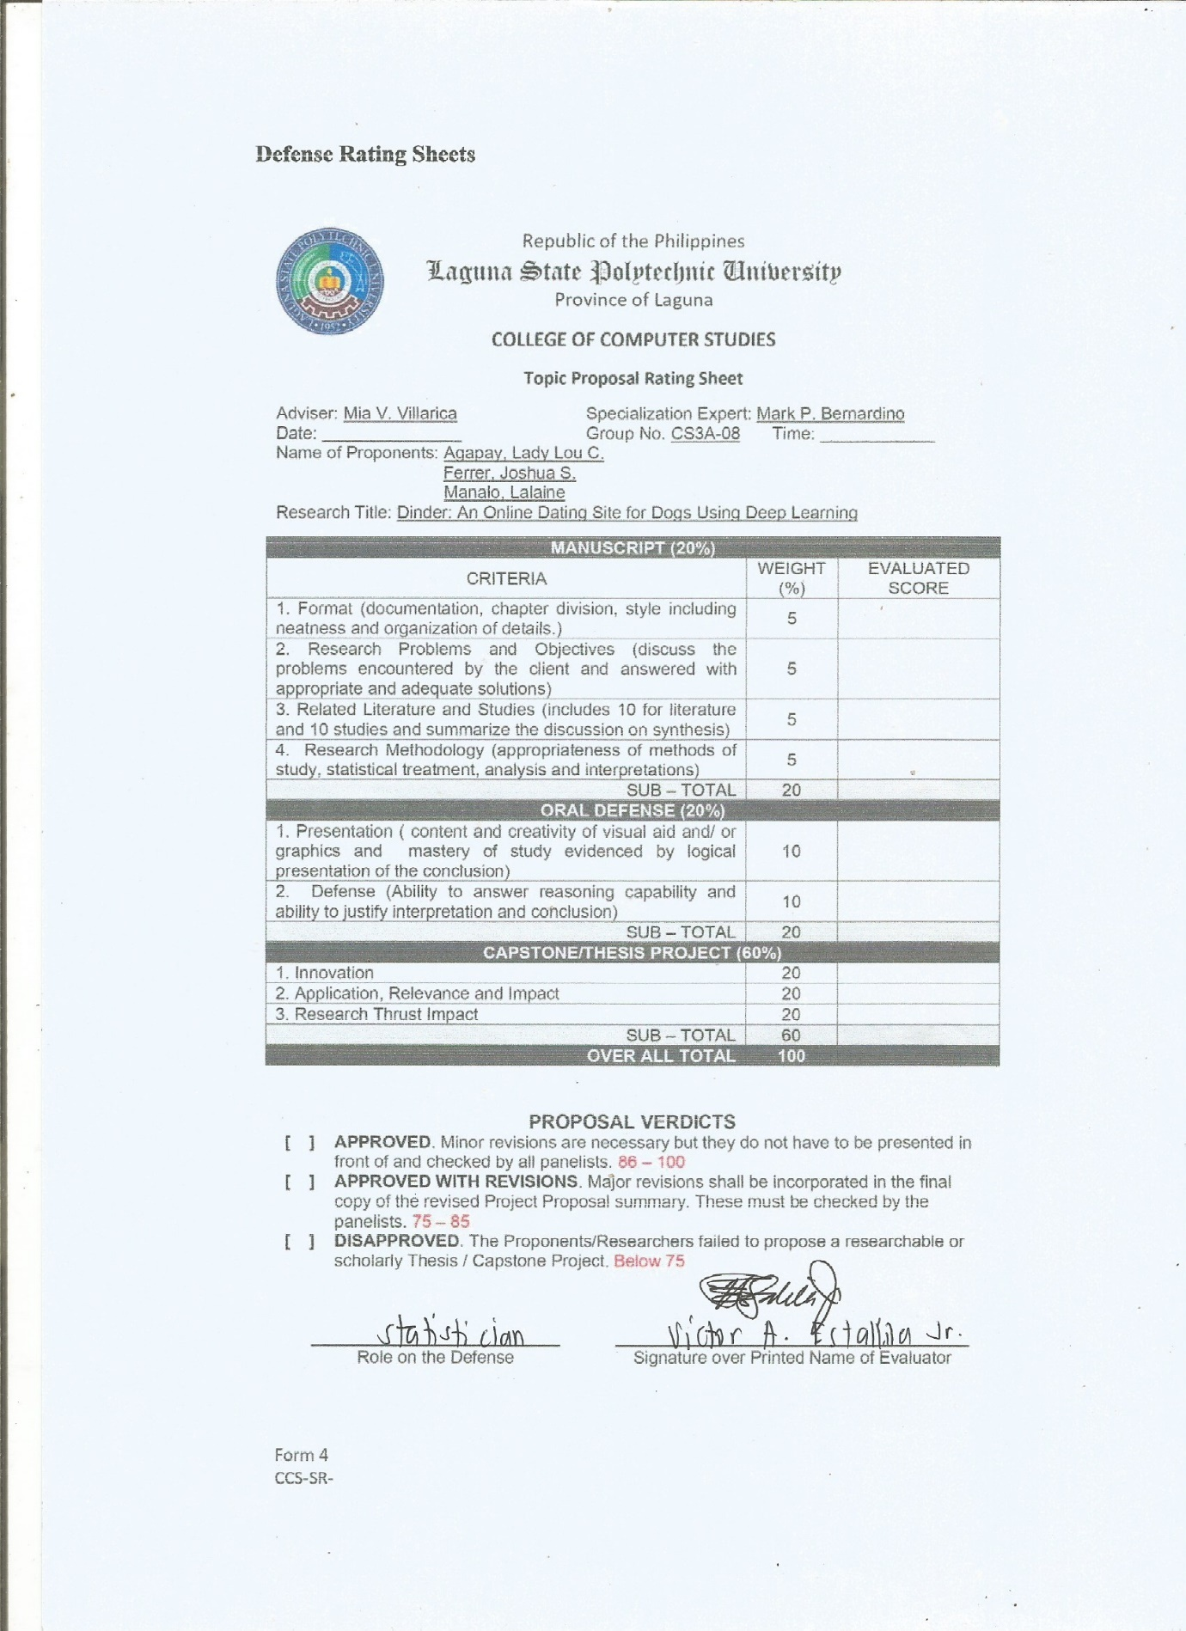



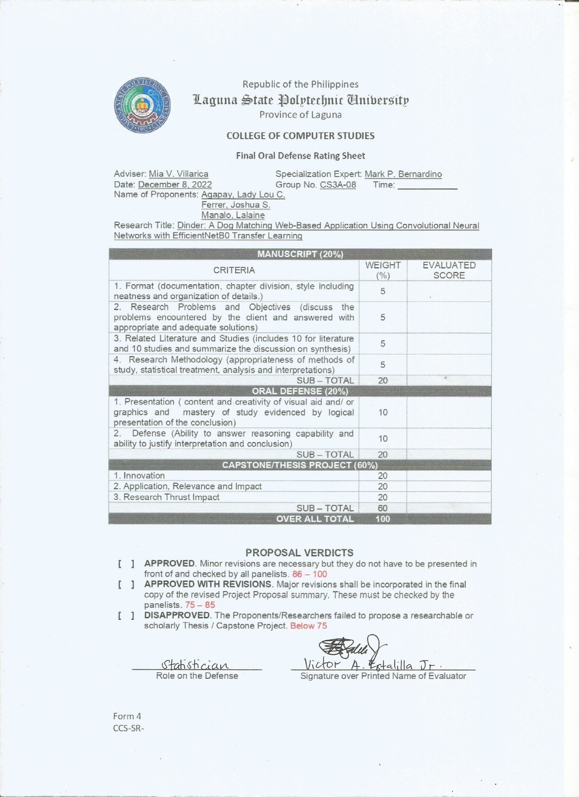







### Summary of Recommendations



## APPENDIX C

Curriculum Vitae





